**URDU MASTER**



**SESSION: 2018 -2022; GROUP ID: G-03**

**PROJECT SUPERVISOR**

MIAN MUHAMMAD MUNIR-UD-DIN

**GROUP MEMBERS**

Hafiz Usama Maqsood 2018-i-3 103 / 029007

Moiz Ajmal 2018-i-45 151 / 029013

Muhammad Ahsan Javaid 2018-i-66 173 / 029014

**A DOCUMENTATION SUBMITTED IN PARTIAL FULFILLMENT OF**

**THE DEGREE OF BS HONOURS IN INFORMATION TECHNOLOGY**

**FROM**

**DEPARTMENT OF THE COMPUTER SCIENCE,**

**GOVT. ISLAMIA GRADUATE COLLEGE, CIVIL LINES, LAHORE**

**AFFILIATED WITH THE UNIVERSITY OF THE PUNJAB, LAHORE**

**CERTIFICATE**

This is to certify that Hafiz Usama Maqsood (103 / 029007), Moiz Ajmal (151 / 029013) and Muhammad Ahsan Javaid (173 / 029014) are the members of Group-03. They have worked on and have completed their software project “URDU MASTER” at Govt. Islamia Graduate College, Civil Lines, Lahore affiliated with the University Of The Punjab, Lahore in the fulfilment of the requirements for the degree of BS Information Technology under my guidance and supervision. By my opinion, it is satisfactory, up to date, and fulfils the requirements of BS Information Technology.

**MIAN MUHAMMAD MUNIR-UD-DIN**

HEAD,

DEPARTMENT OF COMPUTER SCIENCE,

GOVT. ISLAMIA GRADUATE COLLEGE, CIVIL LINES, LAHORE.

Approved By

__________________

(For Office Use Only)

**ACKNOWLEDGEMENT**

A project like this one is never the result of a single person's efforts. The contribution of many people in different ways has made it possible.

We would like to thank ALLAH Almighty, who is the most beneficent, merciful, and blessed us with “Holy Prophet Hazrat MUHAMMAD (S.A.W.W)”. We are thankful to ALLAH Almighty, who blessed us with sound health, kind parents, talented teachers, and intellectual efficiency to complete this project.

It's an honour for us to offer our heartfelt gratitude to our ever-loving supervisor, Mian Muhammad Munir-Ud-Din, Head of Department of Computer Science at Govt. Islamia Graduate College, Civil Lines, Lahore. He helped us to make this project possible. His support, constructive criticism, encouragement, valuable comments, suggestions, timely help throughout the project, and many innovative ideas as well as his pain-taking effort in proofreading the drafts, are greatly appreciated. Indeed, without his guidance, we would not be able to put the topic together.

Last but not least, we would like to thank our loving parents for their unconditional support, both financially and emotionally throughout our degree. In particular, the patience and understanding shown by our families during the BS-Honor years are greatly appreciated.

**Group Members**

Hafiz Usama Maqsood

Moiz Ajmal

Muhammad Ahsan Javaid

**ABSTRACT**

Urdu transliteration and word processing have come into the spotlight in the last decade. As far as Urdu word processors are concerned, modern English word processors have greatly improved their word processing capabilities, but it seems that researchers are mainly on the side of finding solutions or optimizations for a single aspect of the Urdu processing problem. Seem ignorant to you... their integration (as a single text editing solution) is of little importance.

Integrated solutions that meet the needs of modern Urdu content editing are very rare and fragile at this time. In the absence of a compact word processing solution that reflects today's Urdu word processing needs, there is a great need for an Urdu word processor that can justify today's text editing needs of Urdu literate people.

This document describes the features and requirements of a modern Unicode-based Urdu word processor according to today's requirements.  
We also consider a comparative analysis of today's word processing solutions, their pros and cons, and outline what can be done in this area to facilitate Urdu word processing.

**Keywords:**

Urdu word processing, Natural Language Processing, Guidelines for Urdu word editor,

Urdu Editor

Table of Contents

CHAPTER 1 01

INTRODUCTION 01

1.1 Problem Statement 01

1.2 Project Title 02

1.3 Existing System 02

1.4 Drawbacks of Existing System 05

1.5 Proposed System 05

1.6 Project Goals 06

1.7 Project Objectives 07

1.8 Project Scope 07

1.9 Functional Requirements 08

1.10 Non-Functional Requirements 08

1.11 Hardware Specifications 10

1.12 Software Specifications 10

1.13 Gantt Chart 10

1.14 Project Cost Estimation 12

CHAPTER 2 14

LITERATURE REVIEW 14

CHAPTER 3 21

ANALYSIS 21

3.1 Analysis On Method Related To Project 21

3.2 Software Methodology 22

3.3 Analysis on Tools And Software to Be Use 24

CHAPTER 4 26

DESIGN 26

4.1 Use Case Scenarios 26

4.2 Use Case Diagrams 31

4.3 Sequence Diagrams 35

4.4 Activity Diagrams 41

4.5 Collaboration Diagram…………………………………………………………………….42

CHAPTER 5 43

**DATABASE……………………………………………………………………………………..43**

5.1 File Storage………………………………………………………………………………...43

5.2 Opening File…………………..………………………………………………………….45

5.3 Text Area………...….……………………………………………………………………46

5.4 Urdu Keyboard…………………………………………………………………………...47

5.5 Searching………………………………………………………………………………....47

5.6 Text To Speech…………………………………………………………………………...48

CHAPTER 6 50

IMPLEMENTATION 50

6.1 Main User Interface……………………………………………………………………….50

6.2 File Menu………………………………….………….…………………………………...51

6.3 Insert Menu…………………………………...…………………………………………...52

6.4 Edit Menu……………………………………...………………………………………….53

6.5 View Menu……………………………………...………………………………………...54

6.6 Format Menu……………………………………...………………………………………55

6.7 Help Menu……………………………………………...…………………………………56

6.8 Font Style…...………………………………………..…………………………………...57

6.9 Font Size.……..…………………………………………………………………………...58

6.10 Color………………………………………………………..……………………………59

**CHAPTER 7…………………………………………………………………………………….60**

**TESTING………………………………………………………………………………………..60**

7.1 Black Box Testing 60

7.2 Compatibility Testing 60

7.3 Performance Testing 61

7.4 Usability Testing 61

7.5 White Box Testing 61

7.6 Test Cases And Results 62

**CHAPTER 8…………………………………………………………………………………….85**

**CONCLUSION AND FUTURE WORK……………………………………………………...85**

REFERENCES 88

APPENDIX 92

# CHAPTER 1

# INTRODUCTION

Writing is the process of communicate ideas using symbols. It is a system or method of representing language in visual form. Writing is the 4th language skill that learners need to work hard on to master. It's the mirror that reflects or shows one's knowledge about a language. Although it's highly necessary for everybody to be understood in speech, writing as such is at least as important as the ability to speak.

If your students are using inspiration software’s then students can easily create an outline and use this outline as a writing guide. Get your ideas down on paper with images, videos, audio, and voice recordings. They are highly motivated. It can handle media and text. (Castellani & Jeffs, 2001). We are going to create Urdu Master desktop application. Urdu Master is a word processor and page layout software for language such as Urdu under Windows and Apple Mac. Urdu Master is used on PCs where the user wishes to create their documents in Urdu, using the style of Nastalik with a vast ligature library while keeping the display of characters on screen WYSIWYG.

Urdu Master application is like Microsoft Word and InPage applications. This software helps you to write books, newspapers, novels, thesis in Urdu language. This software is usually contains a user which can directly use it. There is no need of an admin in this software. This application is according to the latest requirements of users.

## Problem Statement

InPage Urdu Desktop Application is a system that is the industry standard tools for page making of Newspapers, Magazines and Books in Urdu / Arabic languages. Using the power of Noori Nastalik and Noor character and Faiz Nastalik based fonts InPage gives you the freedom to design your dreams in almost all perso – Arabic scipts like Urdu, Arabic, Persian, Sindhi, Kashmiri Pushto and Hazarag Running on MS Windows, Urdu Master makes publishing not only easy but also enjoyable.

These days almost all Urdu Books publishing work, Students Thesis, TV Drama Scripts, Advertisements and Product Brouchers are being designed on InPage Professional Dekstop publishing system with the help of other Graphic Designing Softwares like Adobe Photoshop and CorelDraw.

Although InPage Professional is very stable and runs error free even with very large files, but still there are chances of its file going corrupt due to various reasons like Flash Drive Pull Out while file was not completely written, very complex formatting of Text Layout, Windows OS Crash problems or Power failure on Desktop PCs.

Once this InPage file goes corrupt, you lose hard work of hours, days, weeks or even months. Just imagine you have been working for 2 months on a college /University Thesis and in last week just before submission, your file goes corrupt and InPage crash every time you open this file.

One more thing I would like to add here is you only get simple text without formatting and may be with some extra special characters here and there. But most definitely, only text is important, character, and paragraph formatting can be applied later.

In this problem statement, I will tell you some other problems with InPage software. Firstly we cannot publish text written in the application directly to other working tools you have to convert the InPage formatted text to internet compatible format. Secondly the use of InPage is very difficult and especially for uneducated people. Thirdly User Interface of InPage is not user friendly. Fourthly Inpage is only capable to open a file whose extension is .inp and not able to open files who have other extensions. Inpage only save file with its extension .inp. InPage need to specialized training to use.

## 1.2 Project Title

Urdu Master

## Existing System

* + 1. **InPage Professional**

InPage V3.0 (stable release) released in 2008, by Concept Software Pvt. Ltd. Its ever first version was released in 1994. The total number of registered users is more than 1,000,000 in Pakistan. Among the other features it provides Spell Checking, conversion into PDF, Unicode support and Object operations. InPage, with more than 1,000,000 registered users in Pakistan, is a major stakeholder in the domain. Its latest version is 2013, still lacking majority of the necessary features.

InPage Urdu is the industry standard tools for page making of Newspapers, Magazines & Books in Urdu. InPage also gives the facility in other languages typing like Arabic, Pashto, Persian and Sindhi in one platform.

InPage Professional is the most popular tool for writing attractive text with color and style themes. It is fully loaded with many new style symbols, themes and Urdu keyboard and widely used over the country.

InPage Professional is a very easy to use, and user-friendly application which consumes very low CPU power. InPage Professional is an excellent application for writing in Urdu. InPage Professional is one of the essential needs of the people active in society from different aspects. for example, social media, business activities, and other similar activities.

**1.3.2 Urdu Editor**

Urdu Editor V8.5, released by Summit Soft. The total downloads of this editor are 116,714 (till 11/03/2014). It has Unicode support, virtual Urdu On-screen keyboard, with user interface in Urdu. Urdu Editor is a full-featured text editor allowing users to type Urdu and English simultaneously. It provides a virtual keyboard on the screen for the Urdu letters and a full bilingual user interface including the Menus, toolbars, Dialogs, and Help. It is easy to compose and print Urdu-English documents, and it also allows users to copy and paste the Urdu text to other applications such as MSWord, Excel, and FrontPage.

* + 1. **Nigar Unicode:**

Nigar Unicode V2.0.1.5, released by AJSoft. The total downloads of this editor are 30,850 (till 11/03/2014). It is a Freeware and provides Unicode sustenance, spell check functionality and exporting as image option as well. The odd side of it is that it has no option to export file as PDF (Portable Document Format), no object operations supported by it, and no blogging at social media sites.

All these editors, available both in industry and literature, provide some basic and advance level functionality, however, still they are lacking too many features that are requirement of any text editor of the day to cover the needs of today’s user.

Urdu Nigar Unicode includes accomplishing of Unicode technology; Support of both Urdu and English in aforementioned argument breadth (simultaneously); Multiline argument support; Support of Phonetic Keyboard; Auto Alignment based on accent selected.

(Right to Left administration and Left to Right direction); Export as an angel (output in GIF format); Spell Check (in Urdu) {checks if an Urdu chat is allotment of concordance or not}; Urdu argument can be affected from Urdu Nigar Unicode and pasted to any Unicode compliant software, you can even forward emails by pasting the argument to the email account provider.

**1.3.4 Comparison of Existing System**

|  |  |  |  |
| --- | --- | --- | --- |
| **Characteristics** | **InPage** | **Urdu Editor** | **Nigar Unicode** |
| Language specific | No | Yes | Yes |
| Save file | Yes | Yes | Yes |
| Image browsing | Yes | No | No |
| Text alignment | Yes | Yes | Yes |
| Searching a word | No | Yes | Yes |
| Font size | Yes | Yes | Yes |
| Colouring | Yes | No | No |
| Image of keyboard | Yes | Yes | Yes |
| Easy to use | No | Yes | Yes |
| Easy availability | Yes | Yes | Yes |
| Fulfill user requirements | No | No | Yes |
| Undo redo words | Yes | No | No |

**Table 1.1 Comparison of existing system**

## Drawbacks of Existing System

There are some drawbacks of InPage Professional software that are:

* The document arrangement is very difficult for new users.
* The other major lack is that you cannot directly published text from Urdu Master into an internet webpage. To publish your typed content, you have to search "InPage” to Unicode Urdu Text Converter" on google and you have to convert the InPage formatted text to internet compatible format.
* The use of InPage is very difficult and especially for uneducated people.
* GUI of InPage is not user friendly.
* Inpage is only capable to open a file whose extension is .inp and not able to open files who have other extensions.
* Inpage only save file with extension .inp
* InPage need to specialized training to use.

## 1.5 Proposed System

After having a closer look and thorough investigation of different Urdu editors and tools and present a list of requirements and features for Urdu Word Processor. This section describes their requirements for the features of the proposed solution Urdu Word Processor (UWP).

There are various additional features that makes the system user friendly. Following Table will look around the basic features that are considered to be present in almost all of the text editing software’s and our proposed solution would integrate them.

|  |  |
| --- | --- |
| **Group** | **Features** |
| **File** | New, Open, Save, Save As, WYSIWYG (Print, Print Preview), Exit |
| **Edit** | Undo, Redo, Copy, Paste, Cut, Search and Replace |
| **View** | Zoom in, Zoom out, Status Bar |
| **Insert** | Time and Date, Symbol, Table, Pictures, Charts |
| **Format** | Alignment [Left, Right, Center, Justify], Text Decoration [Underline, Bold, Italic], Bullets |
| **Custom** | GUI Customization |
| **Font** | Size and Face |
| **Shapes** | Arrows, Boxes, Special Shapes |

**Table 1.2 Proposed system**

## 1.6 Project Goals

The aim of this project is to deploy a desktop application that helps the students, teachers, different types of publishers to write books, notes and thesis in Urdu and different types of publications in Urdu with the following objectives:

* Add a few meaningful features to the product (quality v quantity) that affect how people

use Urdu Master

* To Help People in Writing Books, Newspaper and Magazines in Their Desired Languages
* To explore the problems encountered by the existing system
* Refine existing features
* New context
* Best user experience
* A platform that will provide all required functionalities of Urdu Word Processor

## 1.7 Project Objectives

Urdu Master is used on PCs where the user wishes to create their documents in Urdu, using the style of Nastalik with a vast ligature library while keeping the display of characters on screen WYSIWYG. There is no need for specialized training to learn how to work and user-friendly interface (easy to use)

* To enhanced functionality of existing software
* Write Urdu columns in news papers
* Write applications and letters in Urdu
* Be able to work as professional Urdu composer for any organization
* The creation of simple and easy application software
* The creation of easy to use interface
* This software will help publishers to publish books, magazines, and newspapers
* To edit and format text in different markups. i.e colour, fonts etc

Although default writing style is from right to left but it will allow user to choose whether to write script from left to right (if user is comfortable with it)

## 1.8 Project Scope

After congregating and assembling the cluster of requirements mentioned above, we intend them to be more refined and extended with the passage of time. Our motive is to put those mentioned features into an Urdu Word Processor to live up to the users’ present-day needs regarding word processing. Ahead in near future, we would be developing word processing application that would cater all these features hence, would evolve a new breed of word processing application in computing.

## 1.9 Functional Requirements

Functional requirements are the requirements that the end user specifically demands as basic facilities that the system should offer. All these functionalities need to be necessarily incorporated into the system as a part of the contract. These are represented or stated in the form of input to be given to the system, the operation performed and the output expected.

* Calligraphic style handling of Nastalik script using Nastalik font
* The editing and formatting capabilities of the Urdu Master demonstrate the application's true power
* Text can be inserted, edited, moved, copied or deleted within your document
* The appearance of the text can be modified in numerous ways
* Easy to use and Standardized MS Windows interface with support for all MS Windows platforms
* Full complement of Page Layout features including Pages, textboxes, pictures, text run around and lots of sophisticated typographic control
* Last but not the least has been our end user support and constant endeavour to improve Urdu Master usability and functionality

## 1.10 Non-Functional Requirements

These are basically the quality constraints that the system must satisfy according to the project contract. The priority or extent to which these factors are implemented varies from one project to other. They are also called non-behavioural requirements.  
They basically deal with issues like:

* Availability
* Performance
* Usability
* Compatibility
* Maintainability
* Reliability
* Security

**1.10.1 Availability**

Availability describes how likely a system is accessible for the users. The availability of Urdu Master Desktop Application will be good enough if there is no issue in the system or on the server on which the setup of Urdu Master will be placed. The Urdu Master will be accessible to the users at any time and from anywhere in the world.

**1.10.2 Performance**

Performance defines how fast is a system. Our Urdu Master Desktop Application approximately fulfills all of its functionalities including its quick response to an action which is performed like opening a file, updating a file, saving a file etc. That’s why, the performance of the system will be best and most accurate.

**1.10.3 Usability**

Usability is classical non-functional requirement of the Urdu Master Desktop Application that means how hard it is to use the Urdu Master Desktop Application. The usability of the Urdu Master Application is uncomplicated because Urdu Master Desktop Application has a user-friendly interface. It is very simple and no extraordinary skills are required to use.

**1.10.4 Compatibility**

Compatibility defines how a system or its elements can work in different machines or environments. We have used C# language, Visual Studio software in the development of Urdu Master Desktop Application. We have run our project on Windows Operating System, without any issue.

**1.10.5 Maintainability**

Maintainability defines the time required to fix any problem or any change in the project. The Urdu Master Desktop Application approximately fulfills all of its documented functionalities but in case of any change, the maintenance of the Urdu Master Desktop Application is very easy because every aspect of the Urdu Master Desktop Application has separate files with well managed lines of code.

## 1.11 Hardware Specifications

* CPU: Dual core processor or above
* Hard Disk: 256 GB or above
* RAM: 4 GB or above
* Keyboard
* Mouse

## 1.12 Software Specifications

* Operating System: Windows OS / Mac OS
* Visual Studio .Net

## 1.13 Gantt Chart

The Gantt Chart is representation of the project timeline. It is a type of bar chart that illustrates a project schedule. The Gantt Chart lists the activities that must be performed during the software development process in the given time period. Based on the Work Breakdown Structure (WBS), a Gantt chart shows the project phases on the vertical axis and their corresponding duration of time on the horizontal axis. The duration of an activity corresponds to time period is highlighted by different colours. Modern gantt chart also shows the dependency relationships between activities and current schedule status.

|  |  |  |  |  |  |  |  |  |
| --- | --- | --- | --- | --- | --- | --- | --- | --- |
| **Tasks / Time period** | **13-01-22** | | **01-03-22** | **01-04-22** | **11-05-22** | **01-06-22** | **06-06-22** | **11-06-22** |
| **Requirements gathering** |  | |  |  |  |  |  |  |
| **Documentation** |  |  |  |  |  |  |  |  |
| **Ui designing** |  | |  |  |  |  |  |  |
| **Implementation** |  | |  |  |  |  |  |  |
| **Integration testing** |  | |  |  |  |  |  |  |
| **Bug fixing** |  | |  |  |  |  |  |  |
| **Final testing** |  | |  |  |  |  |  |  |
| **Release version** |  | |  |  |  |  |  |  |

**Table 1.3 Gantt Chart**

**Table 1.4 Chart**

**1.14 Project Cost Estimation**

There are many project cost estimation techniques like Constructive Cost Model – 1 (COCOMO – 1), Constructive Cost Model -2 (COCOMO – 2), Entity Relationship Diagram (ERD) Analysis, Functional Point (FP) Analysis and Lines of Code (LOC) etc. For “Urdu Master” software cost estimation, we are going to use Constructive Cost Model. Constructive Cost Model is a regression model based on **number of Lines of Code (LOC)**. It is a procedural cost estimate model for software projects and is often used as a process of reliably predicting the various parameters associated with making a project such as size, effort, cost, time, and quality.  The key parameters which define the quality of any software products are primarily Effort & Schedule:

* **Effort:** Amount of labor that will be required to complete a task. It is measured in person-months units.
* **Schedule:** Simply means the amount of time required for the completion of the job. It is measured in the units of time such as weeks, months.

|  |  |  |  |  |
| --- | --- | --- | --- | --- |
| **Activity** | **Effort** | **Hours** | **LOC** | **Cost** |
| **Requirements gathering** | 10 | 30 |  | 3000 |
| **Documentation** | 20 | 60 |  | 4000 |
| **Ui designing** | 10 | 40 |  | 5000 |
| **Implementation** | 30 | 130 | 2200 | 40000 |
| **Integration testing** | 12 | 30 |  | 6000 |
| **Bug fixing** | 8 | 40 |  | 7000 |
| **Final testing** | 5 | 20 |  | 5000 |
| **Release version** | 5 | 10 |  | 10000 |
| **Final** | 100% | 360 | 2200 | RS 80000 |

**Table 1.5 Cost Estimation**

The project cost is estimated around RS 87000 (Eighty-Seven Thousand)

**Table 1.6 Cost Estimation Chart**

**CHAPTER 2**

**LITERATURE REVIEW**

Writing on a computer screen is a common feature that is not found in paper-based group writing exercises. Everyone can read it easily and no one owns it or is responsible for it. This encourages the kind of experimentation and risk taking that is often lacking in pen and paper assignments. (D. Eastment, ELT and the New Technology)

All good writing, regardless of writing medium, goes through an authoring cycle that begins with thinking and discussing a subject and taking notes. After prescription, authors can start writing as a first draft. When authors revise and edit texts, they can adopt the ideas of colleagues, teachers and editors about the paper. (Strassman & D’Amore, 2002).

In the writing process, computers and computer software are valuable tools for many students. Additionally, word processing, speech recognition, audio feedback, word prediction, and other types of software packages help students with learning disabilities participate in well-developed classroom writing programs. (Williams, 2002).

The biggest challenge was coming up with a plan for typing Urdu on the keyboard. I mapped my own keyboard using Tavultesoft Keyman software. It was very easy to use. As we have discovered, existing keyboard mappings for written Arabic are generally not phonetically mapped.

In other words, we need to map the Urdu letter feh to the keyboard letter f. Such. Persian, he found a phonetic-mapped keyboard that suited the CRL phonetic layout, so he developed his own keyboard based on that mapping. It doesn't matter if the keyboard layout is standardized or not. He is the only one to enter text. (Computing Research Laboratory, 2002)

Mr. Chikamatsu points out that CALL is becoming popular and becoming the standard in foreign language classes. The researchers examined the impact of computers on the writing efficiency and quality of advanced Japanese learners. One of the results, he said, was that the accuracy rate and the number of kanji characters used differed significantly, suggesting that learners benefit from computerized his writing. (Chikamatsu, 2003)

A neural network is trained on a specific range of spelling errors using a spelling correction system. Back propagation methods are commonly used in training neural networks. (V. J. Hodge and J. Austin 2003).

According to the analysis, word processing first became popular in 1971 and people started thinking about paperless office work to make their repetitive office work easy and fast. more quickly. People started this concept, mainly focusing on English language processing features. Over time, more and more new solutions are added to the existing ones to improve them. (Haigh, T. 2006)

According to Gul, currently Urdu is spoken by 63.4 million people worldwide. In Pakistan, Urdu is the official language and only 20% of the total literate Pakistani population understands English. Therefore, word processor must be in Urdu language for native speakers to fully understand and they can take full advantage of current technology. (S, Gul)

Students begin by deciding what and how to write. Here, students practice various activities such as brainstorming, reading, listening, and quick writing. Brainstorming is an activity in which learners brainstorm an idea to create a process. During this stage, students try to present their ideas on paper in the form of an outline.

Usually the writing process includes a planning phase. Crystal confirms that at this stage “we organize our thoughts and prepare an outline of what we want to say in the document. Even the shortest messages require some planning time. The concept of writing should be supported by the concept of rewriting. “A model of what happens when we write should account for the act of revision, from the early stages of note-taking, annotating, and heading, through various drafts, to the final draft.”Crystal (2006).

The use of word processing in student writing is becoming more and more common, for example, setting out seven ways to develop writers using word processing: Text legibility, Export potential Versions in multiple formats, Ease of modification, Fluent text production (all-compose, no grabs, etc.), Application support (for spelling, grammar, semantic mapping), Portable and easily reproducible electronic documents (easy to share and provide feedback; hard to lose) and Potential for links to electronic source documents.(Graham 2008),

When we need help with complex cognitive and manipulative tasks in our daily lives, we often turn to others. We ask friends to answer questions we cannot answer ourselves. Lighting is no exception. We often enlist friends and colleagues to help shape and refine our writing. But you can't rely on it all the time. Colleagues don't want us to proofread every sentence we write, or delete a few lines from every paragraph in a 10-page essay. (M. Krieger, 2009)

Eyres asserts that "there is no doubt that the editing facilities provided by computers have revolutionized our attitude to errors". If students have access to computers in school, computers will be of great help to students and help them in the writing process. (Eyres, I. 2007)

According to Bergin, people who are fluent in Urdu language only prefer to write documents in their official language because it can improve their productivity for their day-to-day work in their respective fields. Many efforts have been made to solve these problems and companies have come up with their proprietary software. The software is still used by organizations, but some restrictions are maintained in fulfilling their required purposes at different levels of use. (Bergin, T. J. 2006)

According to Lewis, Gary F and Charles D, Urdu is a subset of Arabic language that has attracted great interest among researchers and scholars since its development. Currently, Urdu is spoken in more than 20 countries and 70 million Urdu speakers around the world. Urdu is an official language of Pakistan. (Lewis, M., P., Gary F., S., & Charles D., F. 2013)

InPage is word processing and page layout software for languages ​​such as Urdu, Pesian, Pashto and Arabic on Windows and Mac operating systems, first developed in 1994. It is mainly used to create pages in Urdu language, using Nastaleeq Arabic script. InPage is widely used on PC where users want to create their Urdu documents. Key features are, we can write in multiple languages, page border is standard level, written words are also counted and much more. (<http://www.inpage.com>, 2017)

Liwal Pashto System – Introduced for Windows 98 in 2004 and widely used. This system was his first Windows-based Pashto system, and users could write his Pashto text on most word processors (Microsoft Word, Notepad, WordPad, CorelDraw, etc.).

Pashto fonts are designed by some font designers to replace Urdu characters with Pashto characters, so we replace Urdu characters with Pashto characters and apply this technique to all characters. Installation of new fonts for Arabic script is not supported. (A Practioner’s Approach, 2001)

According to S. Naz and R. Ahmad, text segmentation techniques can divide the Urdu OCR system into three categories, including character-based, ligature-based, and sentence-based systems. Currently, researchers are focusing on his ligature and sentence-based OCR. All of these OCR systems are primarily based on splitting document images into lines of text, ligatures, and characters.

The stylistic complexity of the Urdu Nastaleeq is a major issue in segmentation into lines and ligatures. The main complexity of Nastaleeq's style includes contextuality, compactness, overlap, italics, diagonals, and much more (S. Naz, 2016)

Inam Shamsher proposed a technique for recognition of single characters only and claiming about 98.3 % accuracy. This method is script independent and is used for printed characters only. There is no details provided of given tools or softwares used in the method. (Shamsher Inam, 2007)

Tabassam Nawaz presented an idea for character recognition of isolated characters. This method is proposed by her and works basically in three steps; image pre-processing, segmentation of line and character, making Xml file which is then used as a database and for training purposes. The authors claims 89 % recognition accuracy. (Nawaz Tabassam)

Zaheer Ahmad has published an article on optical character recognition in Urdu for the Nastaleeq font. According to the author, segmentation is divided into three steps. The first step identifies the line of text. The words are separated in the second step, and the last step shows the segmentation and extraction of letters from the words. (Ahmad Zaheer, 2007)

Sobia Tariq Javed only worked in the pre-processing phase. Her work is exclusively for the Nastaleeq style. In the first stage, the horizon or baseline is detected and isolated. The next step is to split the base of the ligature and the chord. (Tariq Sobia, 2009)

The tokenization method is completed through figuring out word obstacles in languages like English wherein punctuation marks or white spaces are used to segregate phrases. Durrani N. And Hussain S. Cope with the orthographic and linguistics capabilities of Urdu language for word segmentation, using a hybrid answer of n-gram ranking with rule based matching heuristics. (D. Nadir, H. Sarmad, 2010)

In English text, words are separated by spaces as tokens. To separate words in Urdu, do not use spaces after each word as in English. Urdu natives separate words from each other when reading and writing texts through cognitive knowledge of the language. (Sara Stymne 2011)

The process of separating and separating a sentence into individual tokens of a word is called word splitting or tokenization. Almost all NLP applications require the text to be split into individual tokens at some stage for processing such as machine translation (MT) and spell checking. In Natural Language Processing (NLP), the terms tokenization or word segmentation are considered the most basic tasks. (A.J mahar 2012 )

Sindhi is the official language of Sindh, Pakistan, spoken by about 34.4 million people in Pakistan and about 2.8 million people in India. The Sindhi script is based on the Persian Arabic script, which is a Nashk Arabic typeface that uses an italic ligature system from right to left. (Ismaili, I.A, 2011)

This post presents ideas on how to find ligatures or letters in larger documents. Nadira Muda also applied her matching approach to the template English alphabet recognition. Mohammed Ali Qatran used a template matching approach for Musnad character recognition. (Qatran, Ali 2011)

According to Raymond. B. Visual Studio Tools for Office (VSTO) includes a complete set of managed APIs, making Word an easy and normal programming environment for .NET developers. There are two ways to create an Office Add-in.

The most common is VSTO and the other is a web add-in. This system uses the VSTO Add-in to perform certain functions using the operating system of the local computer other than the Web. In addition, the development cycle is fast. (Raymond. B, 2018)

According to CraigJ and ScalaIK, each InPage font has a limited number of glyphs for every character to create a complete text in Arabic. The system fails if you enter mixed text. Islamic symbols are excluded from all fonts. It has a limited number of glyphs and no ligatures. Contains up to 4 possible shapes for each character, alternate shapes are not supported. (Designing with Type, the Essential Guide to Typography, 2006)

Spelling errors can therefore also be divided into two categories: typographical errors and cognitive errors. A typo can be defined as a misspelling of a word whose correct spelling is already known, but misspellings occur inadvertently. Typos are primarily related to typing when a word is misspelled because a finger is placed on the wrong key on the keyboard**.** (Waqas A,2014)

According to Wesley A., you need a system that can handle all your text entry needs in a given language. This requires a font that looks good, has all possible characters in different shapes and styles, and doesn't lose text memory. Each font should support texts in different languages ​​of Arabic and Quranic verses.. (Wesley. A, 2000)

Urdu Spell Checker was developed by Urdu Mehfil and has about 1,16,000 words which is less than our application. (Bhurgri M, 2017)

The system uses a hash structure algorithm for fast and efficient lookups. Word analysis and validation also includes validation of error patterns and trends of spelling errors that occur when entering Sindhi text.

Soylent's Shortn component, which references document summaries, has also received significant research attention. Microsoft Word has a summarization feature that uses sentence extraction to identify whole sentences and keep them in passages, discarding the rest. As a result, significant cropping is required, but the content cost is high. (D Marcu,2000)

The proposed model was tested on different corpora of Sindhi texts collected via the Internet (general articles and news articles) and publishers (book chapters and electronic dictionaries). A detailed tokenization report is shown in Table 2. The articles in Sindhi Literary Books were originally typed into the Sindhi word processor using the Sindhi keyboard designed for Sindhi writing. (Z. Bhatti, 2013)

Virtual QWERTY keyboard developed for English. It uses famous phonetic keyboard layout for the convenience of Urdu users. The virtual keyboard also includes shortcut buttons for inserting symbols and buttons for customizing the Urdu keyboard layout. (<http://www.cle.org.pk>)

Mathematical equations are very important in various reports and research work. Most introductory level mathematics books are also in Urdu. Therefore, UWP also requires formulas. We are planning to integrate "MathEditorMini1.0" that generates formulas as images and pastes them into the editor.. (Imran. K, 2015)

Learning and comprehension features are of utmost importance to assess how well PASHAPP provides functionality as per user requirements. While the search mechanism (SM), image browsing (IB) have relatively weak user response, the rest of the features, such as the ability to understand symbols (IU), keyboard layouts (KL), and overall features (OF) yields promising results. Readability of labels indicates comprehension ability. (Muzammil, Khan, 2017)

Currently, researchers are focusing on ligature and sentence-based OCR. All of these OCR systems rely primarily on splitting the document image into lines of text and ligatures. The stylistic complexity of the Urdu Nastaleeq is a major obstacle to the division into lines and ligatures. (Daud A , Khan W , 2017)

**CHAPTER 3**

**ANALYSIS**

**3.1 Analysis on Methods Related to Project**

In this point, the method is discussed that is followed for the development of the Urdu Master desktop application.

The particular Urdu Master refers to the methods and processes of the interaction between People Writing Books, Newspaper and Magazines, Publishing agents, Students writing thesis, Teachers and other staff of institutes.

In this case we are focusing on desktop-based technology as we all know that technology is a very fast-growing network that is growing its roots in everyday life with a fast pace.

**3.1.1 Exploring The Available Techniques**

There is a lot of programming techniques available to be used for such kind of elaborations. The point is to choose such an environment that will be able to operate in a convenient and easy way. This is more or less optional and individual processes that depends on the developer’s experience as well. After searching, we conclude that we will use procedural developing technique and the platform on which we build this software is Visual Studio.

**3.1.2 GUI Construction**

After analyzing the program’s structure and defining what it should contain. A graphical representation of this information is needed to implement to enable the user to interact with the software.

**3.1.3 Testing**

To ensure that everything works properly and as it has been expected, test performance has to be done upon the systems functionality. We are using unit testing for the project. So that the error detection can be done. So that the admin can work on its information system process.

**3.1.4 Time Analysis**

The project should be complete within the specified time period. So time analysis is very necessary. The project is divided into eight different phases and each phase take different time to complete. The first phase Requirement Gathering take time period about 48 days, second phase Documentation take time about 40 days and User interface take time about 15 days etc. Time period of each phase is well defined after a thorough analysis and each phase should complete in that time period.

**3.1.5 Cost Analysis**

The project must complete within the estimated cost. Cost should estimate after thorough analysis and by using cost estimation techniques. Cost of project is estimated about 80000 rupees. The estimated cost is used differently in different phases because each phase has different importance.

Like estimated cost for phase Requirement Gathering is about 3000, Documentation is 4000, User Interface designing is 5000 etc.

**3.2 Software Methodology**

There are many different methods and models which are used by the people according to their work and planning for the development of the software or project. Here, we are going to use Iterative Water Fall Model for development of our URDU MASTER Desktop Based Application because we have read about the working of the model and we believe that it would be easiest and most rewarding model.

It is perfect methodology for our project after analysis of different methodologies. To fulfill our software development requirements, we have selected Iterative Water Fall Model.

**3.2.1 Iterative Waterfall Model**

This development model is compatible with the requirements of our project. This project has variety of features and it ensures the time saving. That is why, we find it best suitable methodology to choose it. Our project is divided already into different phases. We worked in each phase in sequence and sent it to our project supervisor. He well suggested us about the improvement in every phase.

We will improve that phase according to the suggestions. When the phase will be improved and accepted by our project Supervisor then we will advance towards next phase. This will be done due to the waterfall nature of this Model. It is good to detect errors in the same phase in which they are committed.

It reduces the effort and time required to correct the errors. The iterative waterfall model provides feedback paths from every phase to its preceding phases, which is the main difference from the classical waterfall model. It is highly cost-effective to change the plan or requirements in the model. Moreover, it is best suited for agile organizations.

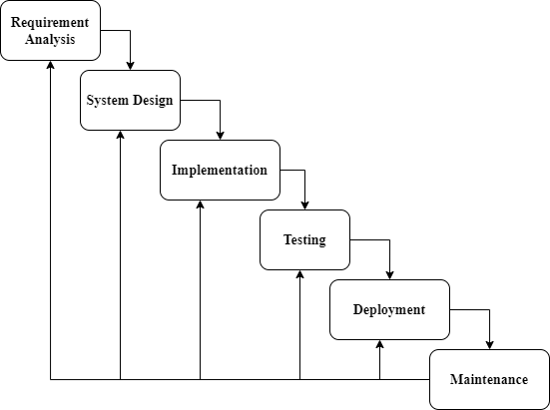

Fig 3.2.1 Iterative waterfall model

**3.3** **Analysis on Tools and Software to Be Used**

In making any type of software or a project there are some tools and software that are used as a helper to develop a software. These tools and software are discussed in the following manner:

**3.3.1 Visual Studio**

Microsoft Visual Studio is an integrated development environment (IDE) from Microsoft. It is used to develop computer programs, as well as websites, web apps, web services, mobile apps and desktop applications. Visual Studio uses Microsoft software development platforms such as Windows API, Windows Forms, Windows Presentation Foundation, Windows Store and Microsoft Silverlight. It can produce both native code and managed code.

Visual Studio .Net works as a compiler of applications we create in C# language. Visual Studio .Net is used to create the software, run the software and test the software we create in C# language. The integrated debugger works both as a source-level debugger and a machine-level debugger.

Other built-in tools include a code profiler, designer for building GUI applications, class designer, and database schema designer. We use Visual studio software to create GUI of the Urdu Master desktop application. Visual studio also works as compiler for our source code. Visual studio provides facility to write code in it.

**3.3.2 .Net Framework**

.Net Framework is a software development platform developed by Microsoft for building and running Windows applications. The .Net framework consists of developer tools, programming languages, and libraries to build desktop and web applications. It is also used to build websites, web services, and games.

The .Net framework was meant to create applications, which would run on the Windows Platform. **.Net Framework Architecture** is a programming model for the .Net platform that provides an execution environment and integration with various programming languages for simple development and deployment of various Windows and desktop applications. It consists of class libraries and reusable components.

The .NET Framework is just that - a programming framework of reusable components that developers can tap into when writing programs so they do not need to reinvent the wheel when they want to connect to a website and download a file, return the square root of a number, manipulate an XML file, control print jobs, compress a data stream, or any of a huge number of other tasks.

Visual Studio is a collection of programming languages, tools, and an IDE for developing programs. This is where the program is actually written, compiled, tested, and packaged for distribution. These languages leverage the .NET Framework to make the development process faster.

**3.3.3 C#**

C# is pronounced as “See Sharp” is a modern, object oriented and component-oriented programming language. We use C# language for the creation of Urdu Master desktop application because it supports may functionalities of our required application. C# helps to create virtual keyboard, text area, different bars with different function. C# help us to create fast, reliable and secure application.

C# also facilitates us to overcome the limitations of the existing software. C# is designed to work with Microsoft's .NET platform. Microsoft's aim is to facilitate the exchange of information and services over the Web, and to enable developers to build highly [portable](https://www.techtarget.com/searchstorage/definition/portability) applications.

C# simplifies programming through its use of Extensible Mark-up Language (XML) and Simple Object Access Protocol ([SOAP](https://www.techtarget.com/searchapparchitecture/definition/SOAP-Simple-Object-Access-Protocol)) which allow access to a programming [object](https://www.techtarget.com/searchapparchitecture/definition/object) or method without requiring the programmer to write additional code for each step. Because programmers can build on existing code, rather than repeatedly duplicating it, C# is expected to make it faster and less expensive to get new products and services to market.

**CHAPTER 4**

**DESIGN**

**4.1 Use Case Scenarios**

**4.1.1 Use Case (CREATE)**

**Id**

UC01

**Brief Description**

User will create file in the application so that the user will be able to use functions and generate the file. Functions are used to insert anything like pictures, shapes, tables etc. or cut, copy and paste, bold, italic and font style etc.

**Primary Actor**

* User

**Pre-conditions**

* First Desktop application must be installed.
* Desktop application should be running properly with no failure.
* The user should be valid.
* Computer or laptop must be available.

**Basic Flow**

* User Open the application.
* User click on the FILE Menu option.
* Open the file menu.
* User click on the New Option or pressed shortcut key (Ctrl + N)
* Than create file in this application.
* The User type the any text in Urdu format and insert the function in this application.

**Post-conditions**

* User will be created file successfully.
* User will be able to use the application to typing urdu format.
* And user will be created newspaper, application in urdu format of this application.
* And insert the picture, shapes, tables and create the designing in this application.

**4.1.2 Use Case (EDIT)**

**Id**

UC02

**Brief Description**

The user will edit and modify the file in this application. User will perform some function ( cut, copy, paste, delete) in this created file. Or user easily text edit in Urdu format.

**Primary Actor**

* User

**Pre-condition**

* Computer or laptop must be available.
* The Application must be installed.
* The file must exist.
* The Application must be running properly.

**Basic Flow**

* User Open the application.
* User click on the Edit Menu option.
* User open the existing file.
* User will edit and modify the text and paragraph according to needs.
* User save the edit file or press shortcut key (Ctrl + S)

**Alternative Flow**

* User does not open the existing file.
* An error message will be displayed that the existing file is not open.
* Sometimes will be displayed that existing file is not occur.
* User again open the existing file and than edit.
* Second case is user create the new file and than perform working.

**Post-condition**

* The User should be able to edit and modify the text and paragraph.
* User should be able to perform many function (cut, copy, paste and clear) in this created file.

**4.1.3 Use Case (SAVE)**

**Id**

UC03

**Brief Description**

The user will save or save as the file in this application. User will create the file, edit file in this application. And then user will save the file in this application. The benefits of saving file is no (data or information) loss.

**Primary Actor**

* User

**Pre-condition**

* Computer or laptop must be available.
* Application must be installed in computer.
* User will create, edited the file must be available in this application.

**Basic Flow**

* User Open the application.
* User click on the FILE Menu option.
* Open the file menu.
* User click on the Save Option.
* The file is saved.

**Post-condition**

* The created file is saved successfully.
* User any time type the text, paragraph and perform many function in this created file, no data lost.

**4.1.4 Use Case (PRINT)**

**Id**

UC04

**Brief Description**

The user will able to print the existing file, edit file.

**Primary Actor**

* User

**Pre-condition**

* Computer or laptop must be available.
* Application must be installed on this computer.
* Created, edited and saved file must be available in this application.
* Printer must be available.

**Basic Flow**

* User Open the application.
* User click on the FILE Menu option.
* Open the file menu.
* User click on the Print Option.
* The create file is print by pressing the command or by typing shortcut key (Ctrl + P)

**Post-condition**

* User created file is printing successfully done.
* User is directed to create option again, and then create the new file and perform the many task again is previous discuss in this application.

**4.2 Use Case Diagram**

**4.2.1 File Creation**

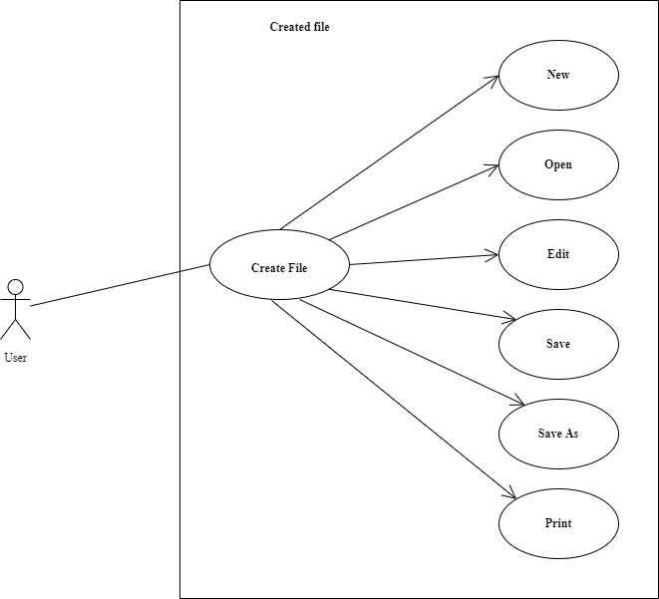

**Figure 4.2.1 File Creation**

**Description**

The above use case diagram show user create the file in urdu master application. The user click on the ‘New’ button and new file is create. And user perform the many task and function apply on this file.

**4.2.2 Edit File**

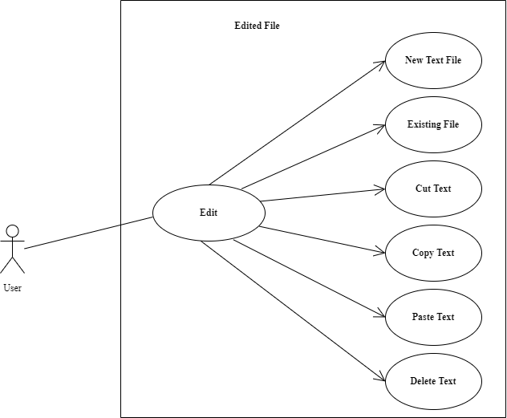

**Figure 4.2.2 Edit File**

**Description**

The above use case diagram show the user edit the existing file. The user copy, past or delete a text in this file. And user perform the many editing function on this file.

**4.2.3 Save File**

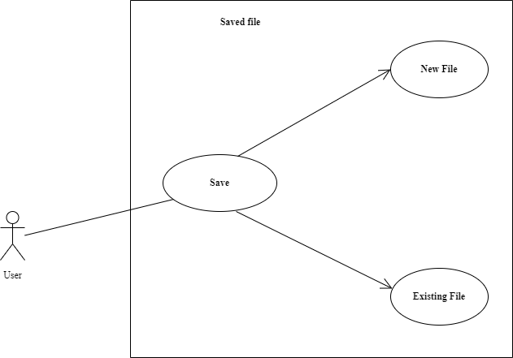

**Figure 4.2.3 Save File**

**Description**

The above use case diagram show the new or existing file savng process. And user any time open the file and perform the such task.

**4.2.4 File Printing**

**Figure 4.2.4 File Printing**

**Description**

The above diagram show the existing or saved file printing process. The user perform many tasks, save the file and then print the file.

**4.3 Sequence Diagrams**

**4.3.1 File Creation**

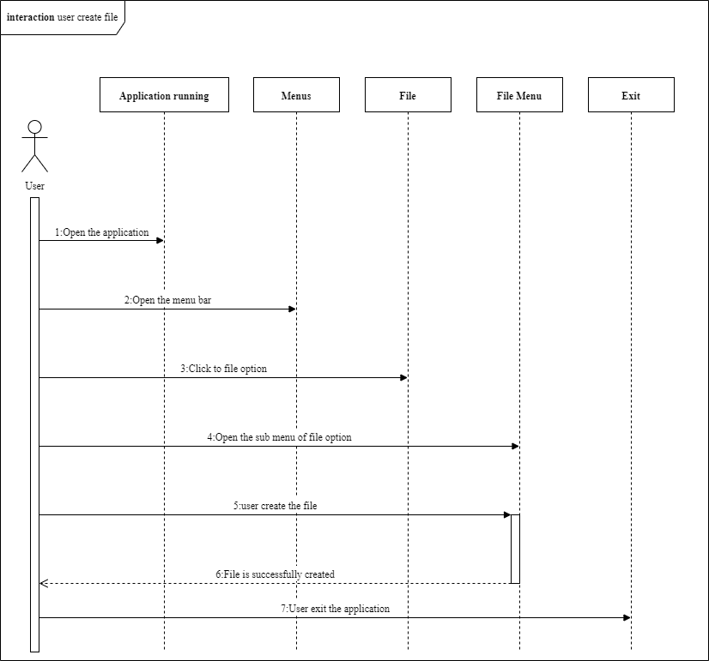

**Figure 4.3.1 File Creation**

**Description**

This Sequence diagram show the user creation file in this application. And application must be running properly with no failure. The user opens the application and open the menu bar. Users click on the file option and submenu of file option is opened. Then user create the file and perform the many function or task in this file.

**4.3.2 Edit File**

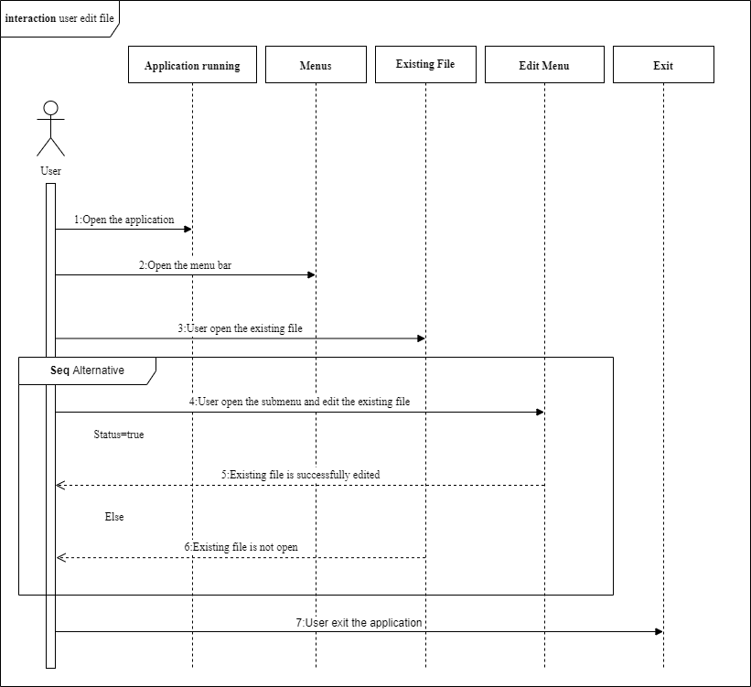

**Figure 4.3.2 Edit File**

**Description**

This Sequence diagram show the user editing in the existing file in this application. Application must be running properly with no failure. Users open the application and thrn open menu. And user open the existing file in this application. Users click on the edit option and submenu of edit option is open. And user editing the existing file is successfully done. Sometimes existing file is not open. Than create the error message in this application. So user again the existing file is opened.

**4.3.3 Save File**

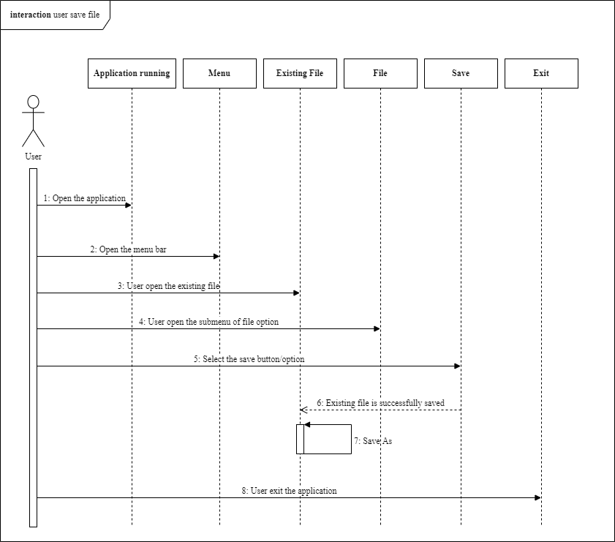

**Figure 4.3.3 Save File**

**Description**

This Sequence diagram show saving of the existing file in this application. The saved file is edit and user click on Save As option. The previous data in this file is replaced with the new data and user saved the file.

**4.3.4 File Printing**

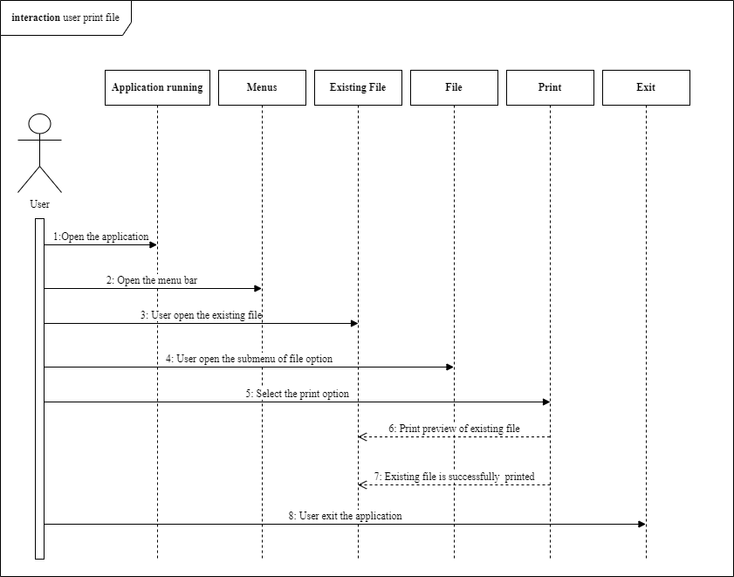

**Figure 4.3.4 File Printing**

**Description**

This Sequence diagram show the user print the existing file in this application.

**4.3.5 Sequence Diagrams for All Cases**

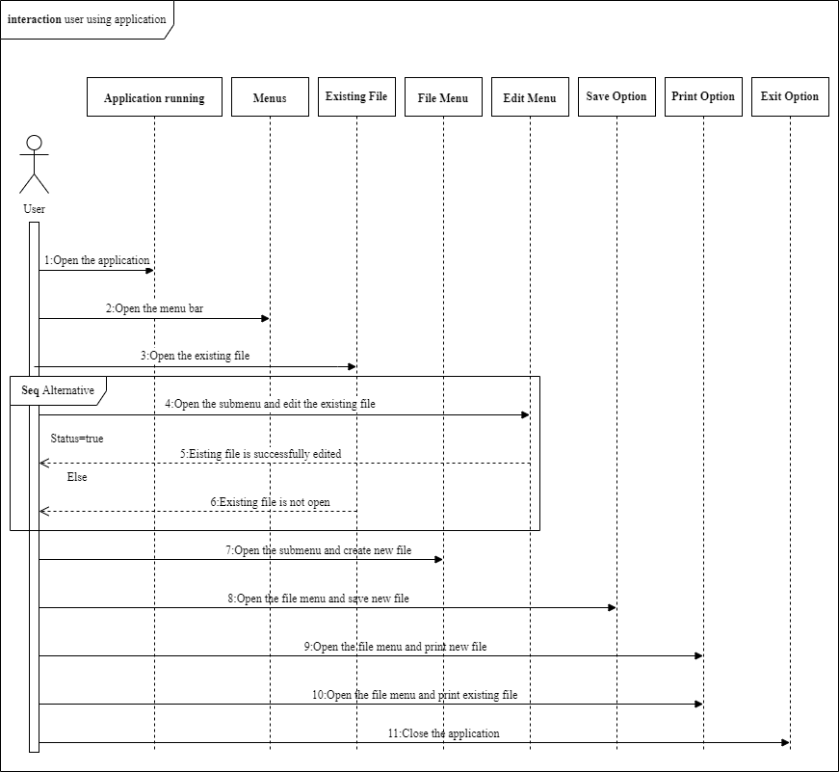

**Figure 4.3.5 All Cases**

**Description**

This Sequence diagram show the working of all caaes.

**4.4 Activity Diagrams**

**4.4.1 Activity Diagram**

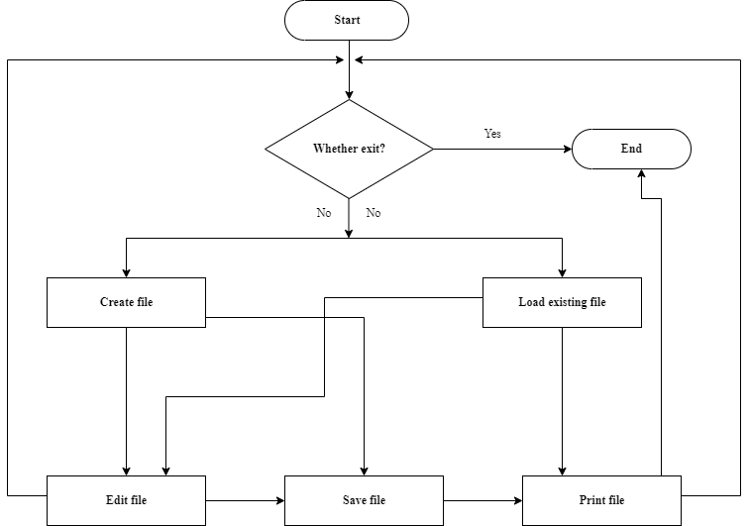

**Figure 4.4**

**4.5 Collaboration Diagram**

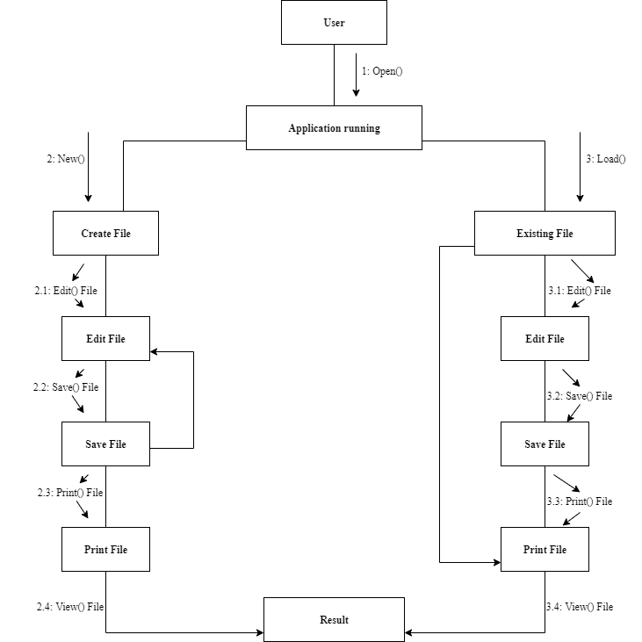

**Figure 4.5**

**CHAPTER 5**

**DATABASE**

In our project there is no need of separate database. All functionalities required by the software (Urdu Master) are almost done by using the tool and programming language in which we create the software. Following are some descriptions of the techniques we use in construction of our desktop application.

**5.1 File Storage:**

Urdu master is a desktop application that is used as a Word processing software. It works similar to other word processing software’s like Microsoft Word. Therefore, we also need to store files in computer system which contains different types of data. For this purpose, we don’t need a separate database to store such files.

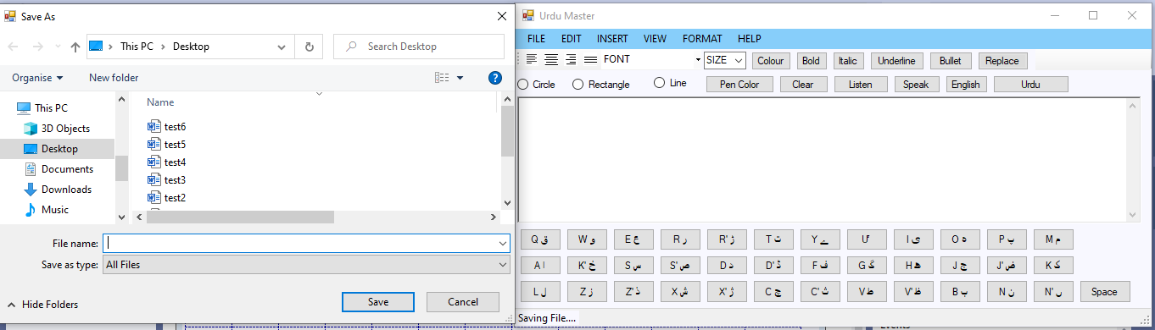

**Figure 5.1.1 Saving a file**

It is the functionality of Visual Studio software that helps to save such files in computer system where we want to save these files like Microsoft Word saves files in computer system, without the need of separate database system. Visual Studio has a function SaveFileDialog that is used to save files in computer system without the need of database.

Similarly, we can also save pictures or images by using this application in the computer system without the need of database. Again, it is the functionality of Visual Studio that helps to store pictures or images in the computer system. We don’t need a separate database for this functionality.

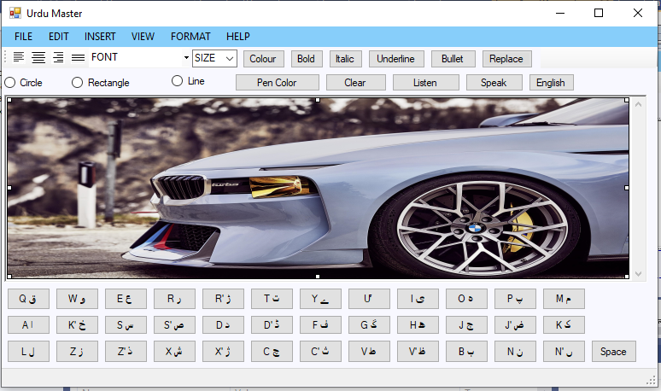

**Figure 5.1.2 Saving Picture**

**5.2 Opening File:**

As discussed above Urdu Master is a word processing application. Therefore, we also need to open a file that is already save in a computer system. We don’t need to use database to open files in our software. It is also the functionality of Visual Studio software that helps to open files containing different types of data in our desktop application. Visual Studio has a function named as OpenFileDialog, which helps to open files in our constructed desktop application.

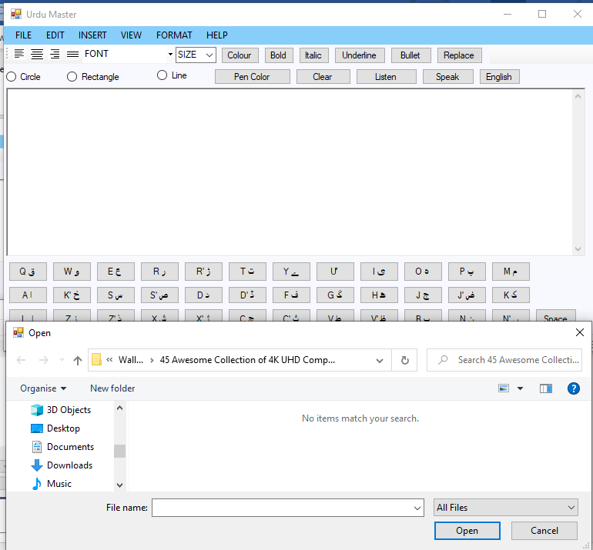

**Figure 5.2 Opening File**

**5.3 Text Area:**

As discussed earlier, Urdu Master is a word processing application. So we also need to type in it. A question arise how we type in Urdu language and where we type in. Again, it is the functionality of tool that we use to construct the application. Visual Studio helps to create a text area where we write and a mechanism to write Urdu language.

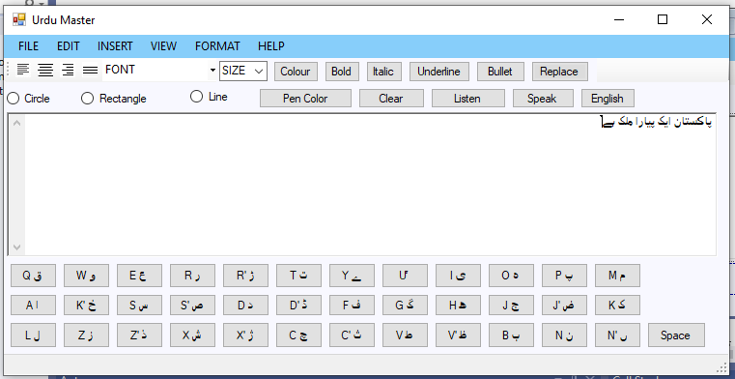

F**igure 5.3 Text Area**

**5.4 Urdu Keyboard:**

We create buttons, by clicking on these buttons we get Urdu characters in text area. Therefore, we can say that we don’t need to use database for typing or writing in Urdu language as this facility is provided by Visual Studio. We get only basic urdu characters by using this technique.

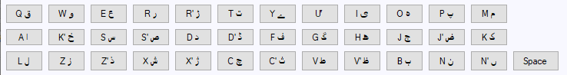**Figure 5.4 Urdu Keyboard**

**5.5 Searching:**

As discussed before, Urdu Master is a word processing application. We also need to search a single character and a complete word like we search in Microsoft Word. We don’t need to store file in database to search a character or word in it. It is the functionality of Visual Studio to save file in a computer system and search a character or word in a file. We don’t need database for this functionality.

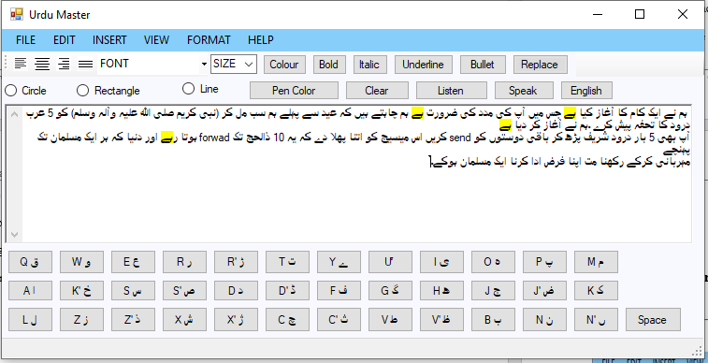

**Figure 5.5 Searching**

**5.6 Text to speech:**

We use text to speech functionality in our application. By using this functionality, we can listen text that we write in the application. The text to speech is also the built-in functionality of the Visual Studio software that we use to build the application. We do not need database for this purpose as stated above it is the functionality of the Visual Studio software.

The purpose of this functionality is to help the visually impaired people by offering a computer-generated spoken voice that would “read” text to the user. This functionality also allows users to see text that they writ, hear it and read it aloud simultaneously.

This technique is also used to help people having trouble in reading. People with learning disabilities who have difficulty in reading large amounts of text due to dyslexia or other problems really benefit from this technique, offering them an easier option for experiencing writing content.

**CHAPTER 6**

**IMPLEMENTATION**

**6.1 Main User Interface**

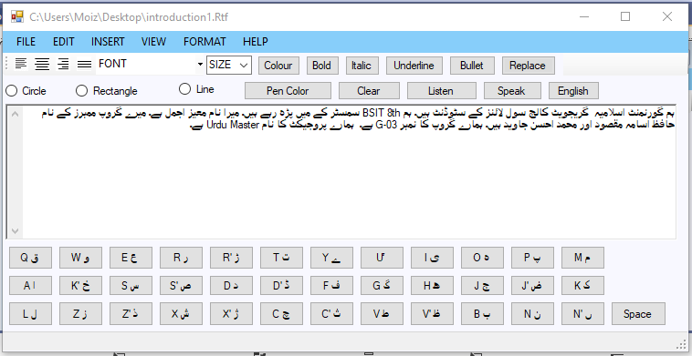

**Figure 6.1**

**6.2 File Menu**

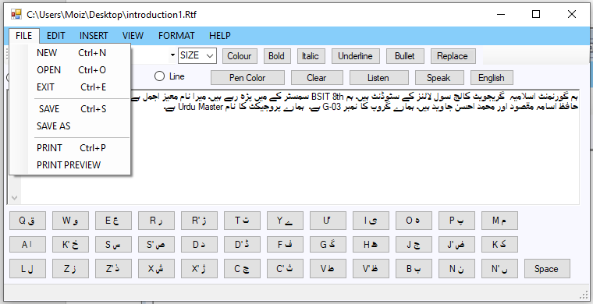

**Figure 6.2**

**6.3 Insert Menu**

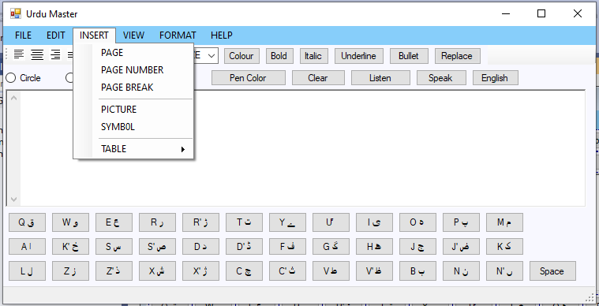

**Figure 6.3**

**6.4 Edit Menu**

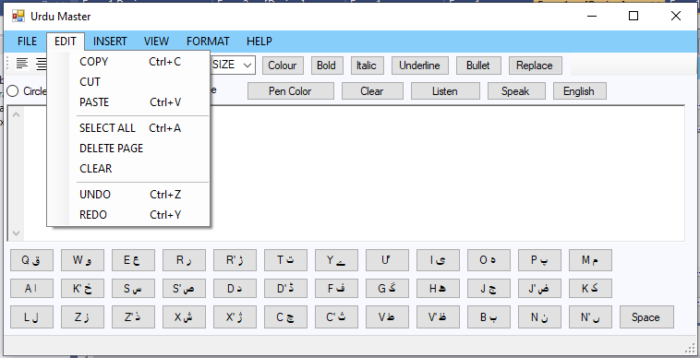

**Figure 6.4**

**6.5 View Menu**

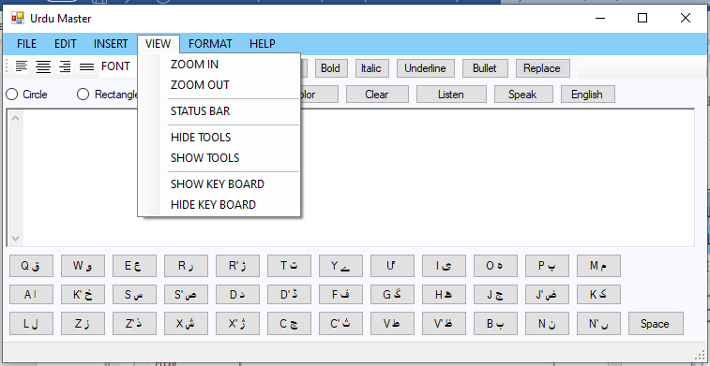

**Figure 6.5**

**6.6 Format Menu**

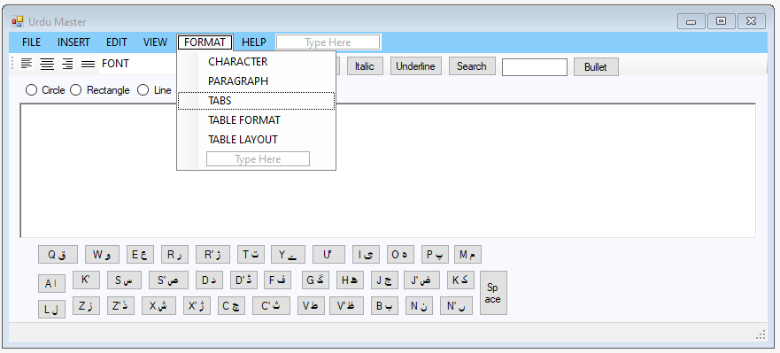

**Figure 6.6**

**6.7 Help Menu**

**Figure 6.7**

**6.8 Font Style**

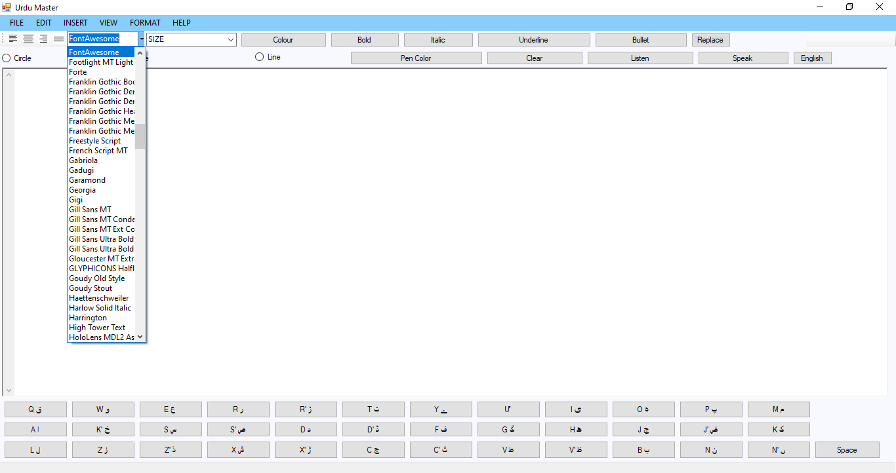

**Figure 6.8**

**6.9 Font Size**

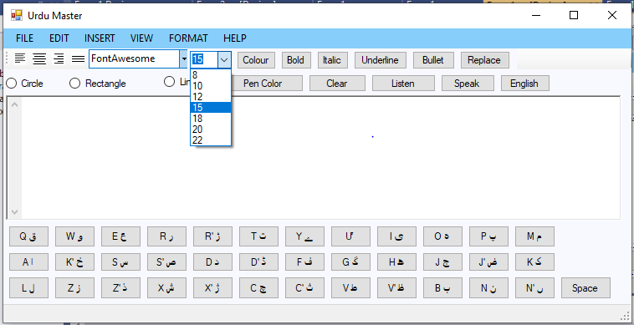

**Figure 6.9**

**6.10 Color**

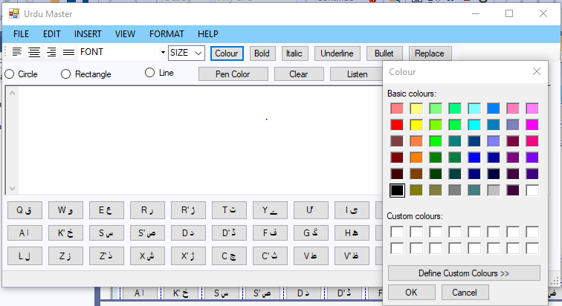

**Figure 6.10**

**CHAPTER 7**

**TESTING AND VERIFICATION**

Software testing is an essential part of software development to verify the functionality of the software because according to the “Pareto Rule”, 80% of errors come from 20% of program components. The techniques often used to test the software under test against the functional or non-functional requirements acquired from the project, are known as software testing techniques.

Each testing method helps in the detection of a certain fault. Techniques that can detect structural

flaws, for example, may not be able to detect flaws in the end-to-end flaws. Hence, multiple testing techniques are applied in the testing of “Urdu Master” to conclude it with acceptable quality.

**7.1 Black Box Testing**

Black box testing involves testing a system in which we have no prior knowledge of its internal workings. A tester provides an input and observes the output generated by the system under test. This makes it possible to identify how the system responds to expected and unexpected user actions, its response time, usability issues and reliability issues.

Black box testing is a powerful testing technique because it exercises a system end-to-end. Just like end-users “don’t care” how a system is coded or architected, and expect to receive an appropriate response to their requests, a tester can simulate user activity and see if the system delivers on its promises.

We tested “Urdu Master” with this technique to check and verify the working of components of the software.

**7.2 Compatibility Testing**

Compatibility testing is a software testing which is performed on an application to check its compatibility on different platforms. This testing is done only when the application becomes stable. The purpose of this compatibility test is to check the developed software application functionality on different software, hardware platforms etc . We have tested our project “Urdu Master ” in different browsers such as Internet Explorer, Google Chrome, Microsoft Edge etc and on different devices with different operating systems such as Windows OS without any issue.

**7.3 Performance Testing**

Performance testing is a testing technique that determines the speed, scalability, and stability of an application under a given workload. It also helps to ensure the quality of the software and makes the application ready to be released into the market. We tested “Urdu Master” with this technique to check the processing speed, data transmission speed, and response times of the system.

We tested “Urdu Master” with this technique to check the processing speed, stability of application, data transmission speed, and response times of the system.

**7.4 Usability Testing**

Usability testing is a testing method for measuring how easy and user friendly a software application is. The main focus of usability testing is on user’s ease of using application and flexibility of application. We can also say that usability testing is a method used to evaluate how easy a website is to use.

We tested “Urdu Master” with this technique to uncover usability flaws and testing easiness of application.

**7.5 White Box Testing**

White box testing techniques analyze the internal structure of the used data structures, internal design, code structure, and working of the software rather than just the functionality as in black box testing. It is also called glass box testing or clear box testing or structural testing. We have tested our project “Urdu Master” with this technique to uncover the logical and structural flaws of the system like logical errors, design errors, syntax errors etc.

**7.6 Test Cases And Results**

A **Test Case** is a set of actions executed to verify a particular feature or functionality of your software application. Test Case acts as the starting point for the test execution, and after applying a set of input values, the application has a definitive outcome and leaves the system at some end point or also known as execution postcondition.

The Test Cases we use contains test steps, test data, precondition, postcondition, expected result, actual result developed for specific test scenario to verify any requirement. These test cases includes specific variables or conditions, using which a tester can compare expected and actual results to determine whether a software product is functioning as per the requirements of the customer or not.

**Test Case Name: Creation of New File**

|  |  |  |
| --- | --- | --- |
| Project Name | Module Name | Test Case ID |
| Urdu Master | Menu Functions | ID-01 |
| Test Case Description | Is a new file create or not? | |
| Test Steps | 1. Start the application 2. Go to menu bar 3. Click on file menu 4. Press **New** button or use shortcut key (**Ctrl + N)** | |
| Test Data | New file create or not? | |
| Pre-Condition | The application is not running successfully. | |
| Post-Condition | New file will open. | |
| Expected Result | New file must create. | |
| Actual Result | New file is created. | |
| Status | Pass | |

**Table 7.1 Test Case of Creation of file**

**Test Case Name: Opening a File**

|  |  |  |
| --- | --- | --- |
| Project Name | Module Name | Test Case ID |
| Urdu Master | Menu Functions | ID-02 |
| Test Case Description | Is a file open or not? | |
| Test Steps | 1. Start the application. 2. Go to menu bar 3. Click on file menu 4. Press **Open** button or press shortcut key **(Ctrl + O)** | |
| Test Data |  | |
| Pre-Condition | File does not exist | |
| Post-Condition | File will open | |
| Expected Result | Required file should open | |
| Actual Result | Required file opens | |
| Status | Pass | |

**Table 7.2 Test Case of Opening a file**

**Test Case Name: Exit from application**

|  |  |  |
| --- | --- | --- |
| Project Name | Module Name | Test Case ID |
| Urdu Master | Menu Functions | ID-03 |
| Test Case Description | The user must able to exit from application | |
| Test Steps | 1. Go to menu bar 2. Open file menu 3. Click on **Exit** button or press shortcut key (**Ctrl + X)** | |
| Test Data |  | |
| Pre-Condition | Application is not running | |
| Post-Condition | Exit from application | |
| Expected Result | Exit from application must happens | |
| Actual Result | Exit from application | |
| Status | Pass | |

**Table 7.3 Test Case of Exit from application**

**Test Case Name: Save**

|  |  |  |
| --- | --- | --- |
| Project Name | Module Name | Test Case ID |
| Urdu Master | Menu Functions | ID-04 |
| Test Case Description | The written or edit file must save | |
| Test Steps | 1. Start the application 2. Open a new file and write in it 3. Open an exist file and edit it 4. Go to menu bar and open file menu 5. Click on **Save** button | |
| Test Data |  | |
| Pre-Condition | The user not opened any type of file | |
| Post-Condition | Fill will save | |
| Expected Result | Required file should be save | |
| Actual Result | File saves | |
| Status | Pass | |

**Table 7.4 Test Case of Saving a file**

**Test Case Name: Save As**

|  |  |  |
| --- | --- | --- |
| Project Name | Module Name | Test Case ID |
| Urdu Master | Menu Functions | ID-05 |
| Test Case Description | The save as function must work on exist file | |
| Test Steps | 1. Start the application 2. Open an exist file 3. Edit it 4. Go to menu bar and open file menu 5. Click on **Save As** button or press key (**Ctrl + S)** | |
| Test Data | The exist file save as or not? | |
| Pre-Condition | File does not exist | |
| Post-Condition | File will save | |
| Expected Result | The save as function must executed successfully | |
| Actual Result | The edited file save as **Save As.** | |
| Status | Pass | |

**Table 7.5 Test Case of Save as**

**Test Case Name: Print**

|  |  |  |
| --- | --- | --- |
| Project Name | Module Name | Test Case ID |
| Urdu Master | Menu Functions | ID-06 |
| Test Case Description | The file must print | |
| Test Steps | 1. Start the application 2. Open a new file and write in it or open an exist file 3. Go to menu bar and open file menu 4. Click on **Print** button or press shortcut key (**Ctrl + P)** | |
| Test Data | The file must print | |
| Pre-Condition | Printer is not attached or some printer issues | |
| Post-Condition | File will print | |
| Expected Result | The required file should print | |
| Actual Result | The function performs well and file is printed | |
| Status | Pass | |

**Table 7.6 Test Case of Print**

**Test Case Name: Print Preview**

|  |  |  |
| --- | --- | --- |
| Project Name | Module Name | Test Case ID |
| Urdu Master | Menu Functions | ID-07 |
| Test Case Description | The print view of file before printing must exist | |
| Test Steps | 1. Start the application 2. Open a new file and write in it or open an exist file 3. Go to menu bar and open file menu 4. Click on **Print Preview** button | |
| Test Data | The virtual print view of a file must exist | |
| Pre-Condition | The length, width and other properties are not specified | |
| Post-Condition | Virtual representation of file will open | |
| Expected Result | The virtual print view of file must open | |
| Actual Result | The virtual print view of file is open and works properly | |
| Status | Pass | |

**Table 7.7 Test Case of Print preview**

**Test Case Name: Copy**

|  |  |  |
| --- | --- | --- |
| Project Name | Module Name | Test Case ID |
| Urdu Master | Menu Functions | ID-08 |
| Test Case Description | The copy function must copy the data | |
| Test Steps | 1. Start the application 2. Open a new file and write in it or open an exist file 3. Select the text 4. Go to menu bar and open edit menu 5. Click on **Copy** button or press shortcut key **(Ctrl + C)** | |
| Test Data | The selected data must copy | |
| Pre-Condition | The text is not selected that is to be copy | |
| Post-Condition | The text will copy | |
| Expected Result | The selected text is expected to be copy | |
| Actual Result | The selected data is copy | |
| Status | Pass | |

**Table 7.8 Test Case of Copy**

**Test Case Name: Cut**

|  |  |  |
| --- | --- | --- |
| Project Name | Module Name | Test Case ID |
| Urdu Master | Menu Functions | ID-09 |
| Test Case Description | The cut function must cut the data | |
| Test Steps | 1. Start the application 2. Open a new file and write in it or open an exist file 3. Select the text 4. Go to menu bar and open edit menu 5. Click on **Cut** button | |
| Test Data | The selected data must cut | |
| Pre-Condition | The text is not selected that is to be cut | |
| Post-Condition | Data will cut | |
| Expected Result | The selected text is expected to be cut | |
| Actual Result | The selected data is successfully cut | |
| Status | Pass | |

**Table 7.9 Test Case of Cut**

**Test Case Name: Paste**

|  |  |  |
| --- | --- | --- |
| Project Name | Module Name | Test Case ID |
| Urdu Master | Menu Functions | ID-10 |
| Test Case Description | The paste function must paste the data | |
| Test Steps | 1. Start the application 2. Open a new file and write in it or open an exist file 3. Select the text and copy it or cut it 4. Go to menu bar and open edit menu 5. Click on **Paste** button or press shortcut key **(Ctrl + V)** | |
| Test Data | The copy or cut data must paste | |
| Pre-Condition | The text is not copy or cut that is to be paste | |
| Post-Condition | Copy text will paste | |
| Expected Result | The copy or cut text is expected to be paste | |
| Actual Result | The copy or cut data is paste successfully | |
| Status | Pass | |

**Table 7.10 Test Case of Paste**

**Test Case Name: Select All**

|  |  |  |
| --- | --- | --- |
| Project Name | Module Name | Test Case ID |
| Urdu Master | Menu Functions | ID-11 |
| Test Case Description | The select all function must select all the data | |
| Test Steps | 1. Start the application 2. Open a new file and write in it or open an exist file 3. Go to menu bar and open edit menu 4. Click on **Select All** button or press shortcut key   **(Ctrl + A)** | |
| Test Data | The all data of a file must select | |
| Pre-Condition | No file is open | |
| Post-Condition | Text will select | |
| Expected Result | The complete text of a file is selected | |
| Actual Result | All text of a file selects | |
| Status | Pass | |

**Table 7.11 Test Case of Select All**

**Test Case Name: Undo**

|  |  |  |
| --- | --- | --- |
| Project Name | Module Name | Test Case ID |
| Urdu Master | Menu Functions | ID-12 |
| Test Case Description | The undo function must undo the data | |
| Test Steps | 1. Start the application 2. Open a new file and write in it or open an exist file 3. Make some changes in the text of a file 4. Go to menu bar and open edit menu 5. Click on **Undo** button or press shortcut key **(Ctrl + Z)** | |
| Test Data | The changes should reverse | |
| Pre-Condition | Changes do not happen in the file | |
| Post-Condition | Text of file will change | |
| Expected Result | The changes make in the file should reverse | |
| Actual Result | The undo function performs successfully | |
| Status | Pass | |

**Table 7.12 Test Case of Undo**

**Test Case Name: Redo**

|  |  |  |
| --- | --- | --- |
| Project Name | Module Name | Test Case ID |
| Urdu Master | Menu Functions | ID-13 |
| Test Case Description | The redo function must redo the data | |
| Test Steps | 1. Start the application 2. Open a new file and write in it or open an exist file 3. Make some changes in the text of a file 4. Go to menu bar and open edit menu 5. Click on **Redo** button or press shortcut key **(Ctrl + Y)** | |
| Test Data | The undo should reverse | |
| Pre-Condition | The undo does not happen in the file | |
| Post-Condition | The operation will undo | |
| Expected Result | The undo made in the file should reverse | |
| Actual Result | The redo function performs successfully | |
| Status | Pass | |

**Table 7.13 Test Case of Redo**

**Test Case Name: Zoom In**

|  |  |  |
| --- | --- | --- |
| Project Name | Module Name | Test Case ID |
| Urdu Master | Zoom In | ID-14 |
| Test Case Description | Users can zoom in to the page. | |
| Test Steps | 1. Start the application 2. Click on view 3. Find zoom in button 4. Choose the zoom in button | |
| Test Data | Zoom in button’s functionality will be tested | |
| Pre-Condition | Application must be in running state | |
| Post-Condition | Zoom in will be performed successfully | |
| Expected Result | Zoom in should be performed successfully | |
| Actual Result | Zoom in is performed successfully | |
| Status | Pass | |

**Table 7.14 Test Case of Zoom In**

**Test Case Name: Zoom Out**

|  |  |  |
| --- | --- | --- |
| Project Name | Module Name | Test Case ID |
| Urdu Master | Zoom Out | ID-15 |
| Test Case Description | Users can zoom out the page | |
| Test Steps | 1. Start the application 2. Click on view 3. Find Zoom out button 4. Choose the zoom out button | |
| Test Data | Zoom out button’s functionality will be tested | |
| Pre-Condition | Application must be in running state | |
| Post-Condition | Zoom out will be performed successfully | |
| Expected Result | Zoom out should be performed successfully | |
| Actual Result | Zoom out is performed successfully | |
| Status | Pass | |

**Table 7.15 Test Case of Zoom Out**

**Test Case Name: Status Bar**

|  |  |  |
| --- | --- | --- |
| Project Name | Module Name | Test Case ID |
| Urdu Master | Status bar | ID-16 |
| Test Case Description | Users can view various kind of status information | |
| Test Steps | 1. Start the application 2. Status bar appears bottom of the application. 3. Status bar shows name of task performing | |
| Test Data | Status bar button’s functionality will be tested | |
| Pre-Condition | Application must be in running state | |
| Post-Condition | Status information can be viewed successfully | |
| Expected Result | Status information should be performed successfully | |
| Actual Result | Status information is viewed successfully | |
| Status | Pass | |

**Table 7.16 Test Case of Status Bar**

**Test Case Name: Hide Tools**

|  |  |  |
| --- | --- | --- |
| Project Name | Module Name | Test Case ID |
| Urdu Master | Hide tools | ID-17 |
| Test Case Description | Users can hide that tool which they want | |
| Test Steps | 1. Start the application 2. Click on view 3. Find hide tools button 4. Choose the hide tools buttons | |
| Test Data | Hide tools button’s functionality will be tested | |
| Pre-Condition | Application must be in running state | |
| Post-Condition | Tools will be hidden successfully | |
| Expected Result | Tools should be hidden successfully | |
| Actual Result | Tools are hidden successfully | |
| Status | Pass | |

**Table 7.17 Test Case of Hide Tools**

**Test Case Name: Show Tools**

|  |  |  |
| --- | --- | --- |
| Project Name | Module Name | Test Case ID |
| Urdu Master | Show Tools | ID-18 |
| Test Case Description | Users can display tools of the application | |
| Test Steps | 1. Run the application 2. Click on view 3. Find show tools button 4. Choose show tools button | |
| Test Data | Show tools button’s functionality will be tested | |
| Pre-Condition | Application must be in running state | |
| Post-Condition | Tools will be display successfully | |
| Expected Result | Tools should be display successfully | |
| Actual Result | Tools are display successfully | |
| Status | Pass | |

**Table 7.18 Test Case of Show Tools**

**Test Case Name: Show Keyboard**

|  |  |  |
| --- | --- | --- |
| Project Name | Module Name | Test Case ID |
| Urdu Master | Show keyboard | ID-19 |
| Test Case Description | Users can display keyboard of the application | |
| Test Steps | 1. Run the application 2. Click on view 3. Find show keyboard button 4. Choose show keyboard button | |
| Test Data | Show keyboard button’s functionality will be tested | |
| Pre-Condition | Application must be in running state | |
| Post-Condition | Keyboard will be display successfully | |
| Expected Result | Keyboard should be display successfully | |
| Actual Result | Keyboard is display successfully | |
| Status | Pass | |

**Table 7.19 Test Case of Character**

**Test Case Name: Paragraph**

|  |  |  |
| --- | --- | --- |
| Project Name | Module Name | Test Case ID |
| Urdu Master | Paragraph | ID-20 |
| Test Case Description | Users can change the format of the paragraph | |
| Test Steps | 1. Run the application 2. Click on view 3. Find hide keyboard button 4. Choose hide keyboard button | |
| Test Data | Hide keyboard button’s functionality will be tested | |
| Pre-Condition | Application must be in running state | |
| Post-Condition | Keyboard will be hide successfully | |
| Expected Result | Keyboard should be hide successfully | |
| Actual Result | Keyboard is hide successfully | |
| Status | Pass | |

**Table 7.20 Test Case of Paragraph**

**Test Case Name: Hide Keyboard**

|  |  |  |
| --- | --- | --- |
| Project Name | Module Name | Test Case ID |
| Urdu Master | Hide keyboard | ID-21 |
| Test Case Description | Users can hide keyboard of the application | |
| Test Steps | 1. Run the application 2. Click on format 3. Find PARAGRAPH option 4. Choose the PARAGRAPH button | |
| Test Data | Paragraph format button’s functionality will be tested | |
| Pre-Condition | Application must be in running state | |
| Post-Condition | Format of the paragraph will be changed successfully | |
| Expected Result | Format of the paragraph should be changed successfully | |
| Actual Result | Format of the paragraph is changed successfully | |
| Status | Pass | |

**Table 7.21 Test Case of Tabs**

**Test Case Name: Table Format**

|  |  |  |
| --- | --- | --- |
| Project Name | Module Name | Test Case ID |
| Urdu Master | Table format | ID-22 |
| Test Case Description | Users can change format of the table | |
| Test Steps | 1. Start the application 2. Click on format 3. Find Table format option 4. Choose the table format button | |
| Test Data | Table format button’s functionality will be tested | |
| Pre-Condition | Application must be in running state | |
| Post-Condition | Format of the table will be changed successfully | |
| Expected Result | Format of the table should be changed successfully | |
| Actual Result | Format of the table is changed successfully | |
| Status | Pass | |

**Table 7.22 Test Case of Table Format**

**Test Case Name: Table Layout**

|  |  |  |
| --- | --- | --- |
| Project Name | Module Name | Test Case ID |
| Urdu Master | Table layout | ID-23 |
| Test Case Description | Users can change layout of the table | |
| Test Steps | 1. Start the application 2. Click on format 3. Find Table layout option 4. Choose the table layout button | |
| Test Data | Table layout button’s functionality will be tested | |
| Pre-Condition | Application must be in running state | |
| Post-Condition | Layout of the table will be changed successfully | |
| Expected Result | Layout of the table should be changed successfully | |
| Actual Result | Layout of the table is changed successfully | |
| Status | Pass | |

**Table 7.23 Test Case of Table Layout**

**Test Case Name: Page**

|  |  |  |
| --- | --- | --- |
| Project Name | Module Name | Test Case ID |
| Urdu Master | Page | ID-24 |
| Test Case Description | Users can insert new page | |
| Test Steps | 1. Run the application 2. Click on insert 3. Find Page option 4. Choose the page button | |
| Test Data | Insert page button’s functionality will be tested | |
| Pre-Condition | Application must be in running state | |
| Post-Condition | Page will be inserted successfully | |
| Expected Result | Page should be inserted successfully | |
| Actual Result | Page is inserted successfully | |
| Status | Pass | |

**Table 7.24 Test Case of Page**

**Test Case Name: Page Number**

|  |  |  |
| --- | --- | --- |
| Project Name | Module Name | Test Case ID |
| Urdu Master | Page number | ID-25 |
| Test Case Description | Users can insert page number | |
| Test Steps | 1. Run the application 2. Click on insert 3. Find Page number option 4. Choose the page number button | |
| Test Data | Insert page number button’s functionality will be tested | |
| Pre-Condition | Application must be in running state | |
| Post-Condition | Page number will be inserted successfully | |
| Expected Result | Page number should be inserted successfully | |
| Actual Result | Page number is inserted successfully | |
| Status | Pass | |

**Table 7.25 Test Case of Page Number**

**Test Case Name: Page Break**

|  |  |  |
| --- | --- | --- |
| Project Name | Module Name | Test Case ID |
| Urdu Master | Page break | ID-26 |
| Test Case Description | Users can split document pages into section | |
| Test Steps | 1. Start the application 2. Click on insert 3. Find Page break option 4. Choose the page break button | |
| Test Data | Page break button’s functionality will be tested | |
| Pre-Condition | Application must be in running state | |
| Post-Condition | Page break will be applied successfully | |
| Expected Result | Page break should be applied successfully | |
| Actual Result | Page break is applied successfully | |
| Status | Pass | |

**Table 7.26 Test Case of Page Breaks**

**Test Case Name: Picture**

|  |  |  |
| --- | --- | --- |
| Project Name | Module Name | Test Case ID |
| Urdu Master | Picture | ID-27 |
| Test Case Description | Users can insert picture into the document | |
| Test Steps | 1. Start the application 2. Click on insert 3. Find Picture option 4. Choose the picture button | |
| Test Data | Insert picture button’s functionality will be tested | |
| Pre-Condition | Application must be in running state | |
| Post-Condition | Picture will be inserted successfully | |
| Expected Result | Picture should be inserted successfully | |
| Actual Result | Picture is inserted successfully | |
| Status | Pass | |

**Table 7.27 Test Case of Picture**

**Test Case Name: Symbol**

|  |  |  |
| --- | --- | --- |
| Project Name | Module Name | Test Case ID |
| Urdu Master | Symbol | ID-28 |
| Test Case Description | Users can insert symbol and special characters in document | |
| Test Steps | 1. Run the application 2. Click on insert 3. Find Symbol option 4. Choose the symbol button | |
| Test Data | Insert symbol button’s functionality will be tested | |
| Pre-Condition | Application must be in running state | |
| Post-Condition | Symbol or special character will be inserted successfully | |
| Expected Result | Symbol or special character should be inserted successfully | |
| Actual Result | Symbol or special character is inserted successfully | |
| Status | Pass | |

**Table 7.28 Test Case of Symbol**

**Test Case Name: Table**

|  |  |  |
| --- | --- | --- |
| Project Name | Module Name | Test Case ID |
| Urdu Master | Table | ID-29 |
| Test Case Description | Users can insert table into the document | |
| Test Steps | 1. Run the application 2. Click on insert 3. Find Table option 4. Choose the table button | |
| Test Data | Insert table button’s functionality will be tested | |
| Pre-Condition | Application must be in running state | |
| Post-Condition | Table will be inserted successfully | |
| Expected Result | Table should be inserted successfully | |
| Actual Result | Table is inserted successfully | |
| Status | Pass | |

**Table 7.29 Test Case of Table**

**Test Case Name: Time and Date**

|  |  |  |
| --- | --- | --- |
| Project Name | Module Name | Test Case ID |
| Urdu Master | Time and Date | ID-30 |
| Test Case Description | Users can insert time and date into the document | |
| Test Steps | 1. Start the application 2. Click on insert 3. Find Time and date option 4. Choose the Time and date button | |
| Test Data | Insert Time and date button’s functionality will be tested | |
| Pre-Condition | Application must be in running state | |
| Post-Condition | Time and date will be inserted successfully | |
| Expected Result | Time and date should be inserted successfully | |
| Actual Result | Time and date is inserted successfully | |
| Status | Pass | |

**Table 7.30 Test Case of Time and Date**

**Test Case Name: Index**

|  |  |  |
| --- | --- | --- |
| Project Name | Module Name | Test Case ID |
| Urdu Master | Index | ID-31 |
| Test Case Description | Users can view topics that are inserted into the document | |
| Test Steps | 1. Start the application 2. Click on help 3. Find Index option 4. Choose the Index button | |
| Test Data | Index button’s functionality will be tested | |
| Pre-Condition | Application must be in running state | |
| Post-Condition | Topics that are inserted can be viewed successfully | |
| Expected Result | Topics that are inserted should be viewed successfully | |
| Actual Result | Topics that are inserted is viewed successfully | |
| Status | Pass | |

**Table 7.31 Test Case of Index**

**Test Case Name: Shortcut**

|  |  |  |
| --- | --- | --- |
| Project Name | Module Name | Test Case ID |
| Urdu Master | Shortcut | ID-32 |
| Test Case Description | Users can view shortcut keys for different operations | |
| Test Steps | 1. Start the application 2. Click on help 3. Find shortcut option 4. Choose the shortcut button | |
| Test Data | Shortcut button’s functionality will be tested | |
| Pre-Condition | Application must be in running state | |
| Post-Condition | Shortcut keys that are inserted can be viewed successfully | |
| Expected Result | Shortcut keys that are inserted should be viewed successfully | |
| Actual Result | Shortcut keys that are inserted is viewed successfully | |
| Status | Pass | |

**Table 7.32 Test Case of Shortcut**

**Test Case Name: Text To Speech**

|  |  |  |
| --- | --- | --- |
| Project Name | Module Name | Test Case ID |
| Urdu Master | Text t To Speech | ID-33 |
| Test Case Description | Users can convert text into speech or listen what they write | |
| Test Steps | 1. Start the application 2. Write something in the file or open existing file 3. Click on listen button | |
| Test Data | The text must be converted into speech | |
| Pre-Condition | Application must be in running state | |
| Post-Condition | Text will not convert into speech | |
| Expected Result | Text should be converted into speech | |
| Actual Result | Text is converted into speech | |
| Status | Pass | |

**Table 7.33 Test Case of GUI Responsiveness**

**Test Case Name: Title**

|  |  |  |
| --- | --- | --- |
| Project Name | Module Name | Test Case ID |
| Urdu Master | Title | ID-34 |
| Test Case Description | Users can view title of document | |
| Test Steps | 1. Start the application 2. Click on window 3. Find Title option 4. Choose the Title button | |
| Test Data | Title button’s functionality will be tested | |
| Pre-Condition | Application must be in running state | |
| Post-Condition | Title that is inserted can be viewed successfully | |
| Expected Result | Title that is inserted should be viewed successfully | |
| Actual Result | Title that is inserted is viewed successfully | |
| Status | Pass | |

**Table 7.34 Test Case of Title**

**Test Case Name: Ribon**

|  |  |  |
| --- | --- | --- |
| Project Name | Module Name | Test Case ID |
| Urdu Master | Ribon | ID-36 |
| Test Case Description | Users can view Ribon of seven tabs in document | |
| Test Steps | 1. Run the application 2. Click on window 3. Find Ribon option 4. Choose the Ribon button | |
| Test Data | Ribon button’s functionality will be tested | |
| Pre-Condition | Application must be in running state | |
| Post-Condition | Ribon that is inserted can be applied successfully | |
| Expected Result | Ribon that is inserted should be applied successfully | |
| Actual Result | Ribon that is inserted is applied successfully | |
| Status | Pass | |

**Table 7.36 Test Case of Ribon**

**Test Case Name: Close All**

|  |  |  |
| --- | --- | --- |
| Project Name | Module Name | Test Case ID |
| Urdu Master | Close all | ID-37 |
| Test Case Description | Users can close all tabs in document | |
| Test Steps | 1. Start the application 2. Click on window 3. Find Close all option 4. Choose the Close all button | |
| Test Data | Close all button’s functionality will be tested | |
| Pre-Condition | Application must be in running state | |
| Post-Condition | Pages that are inserted can be closed successfully | |
| Expected Result | Pages that is inserted should be closed successfully | |
| Actual Result | Pages that is inserted is closed successfully | |
| Status | Pass | |

**Table 7.37 Test Case of Close all**

**Test Case Name: Font**

|  |  |  |
| --- | --- | --- |
| Project Name | Module Name | Test Case ID |
| Urdu Master | FONT | ID-38 |
| Test Case Description | Users can change font of the text | |
| Test Steps | 1. Run the application 2. Click on FONT button 3. Find your appropriate FONT 4. Choose that FONT | |
| Test Data | FONT button’s functionality will be tested | |
| Pre-Condition | Application must be in running state | |
| Post-Condition | FONTS that are inserted can be applied successfully | |
| Expected Result | FONTS that is inserted should be applied successfully | |
| Actual Result | FONTS that is inserted is applied successfully | |
| Status | Pass | |

**Table 7.38 Test Case of Font**

**Test Case Name: Colour**

|  |  |  |
| --- | --- | --- |
| Project Name | Module Name | Test Case ID |
| Urdu Master | Colour | ID-39 |
| Test Case Description | Users can change colour of the text | |
| Test Steps | 1. Run the application 2. Click on Colour button 3. Find your appropriate Colour 4. Choose that Colour | |
| Test Data | Colour button’s functionality will be tested | |
| Pre-Condition | Application must be in running state | |
| Post-Condition | Colour that are inserted can be applied successfully | |
| Expected Result | Colour that is inserted should be applied successfully | |
| Actual Result | Colour that is inserted is applied successfully | |
| Status | Pass | |

**Table 7.39 Test Case of Colour**

**Test Case Name: Bold**

|  |  |  |
| --- | --- | --- |
| Project Name | Module Name | Test Case ID |
| Urdu Master | Bold | ID-40 |
| Test Case Description | Users can change boldness of the text | |
| Test Steps | 1. Start the application 2. Select the text to which you to apply bold 3. Click on Bold button 4. Boldness will be applied | |
| Test Data | Bold button’s functionality will be tested | |
| Pre-Condition | Application must be in running state | |
| Post-Condition | Bold that is inserted can be applied successfully | |
| Expected Result | Bold that is inserted should be applied successfully | |
| Actual Result | Bold that is inserted is applied successfully | |
| Status | Pass | |

**Table 7.40 Test Case of Bold**

**Test Case Name: Italic**

|  |  |  |
| --- | --- | --- |
| Project Name | Module Name | Test Case ID |
| Urdu Master | Italic | ID-41 |
| Test Case Description | Users can italicize the text of document | |
| Test Steps | 1. Run the application 2. Select the text to which you want to italicize 3. Click on Italic button 4. Italicize will be applied | |
| Test Data | Italic button’s functionality will be tested | |
| Pre-Condition | Application must be in running state | |
| Post-Condition | Italic that is inserted can be applied successfully | |
| Expected Result | Italic that is inserted should be applied successfully | |
| Actual Result | Italic that is inserted is applied successfully | |
| Status | Pass | |

**Table 7.41 Test Case of Italic**

**Test Case Name: Underline**

|  |  |  |
| --- | --- | --- |
| Project Name | Module Name | Test Case ID |
| Urdu Master | Underline | ID-42 |
| Test Case Description | Users can underline the text of document | |
| Test Steps | 1. Start the application 2. Select the text to which you want to underline 3. Click on underline button 4. Underline will be applied | |
| Test Data | Underline button’s functionality will be tested | |
| Pre-Condition | Application must be in running state | |
| Post-Condition | Underline that is inserted can be applied successfully | |
| Expected Result | Underline that is inserted should be applied successfully | |
| Actual Result | Underline that is inserted is applied successfully | |
| Status | Pass | |

**Table 7.42 Test Case of Underline**

**Test Case Name: Search**

|  |  |  |
| --- | --- | --- |
| Project Name | Module Name | Test Case ID |
| Urdu Master | Search | ID-43 |
| Test Case Description | Users can search any word in the text of document | |
| Test Steps | 1. Run the application 2. Click on search button 3. Type any word in search button 4. All the matched words will be shown | |
| Test Data | Search button’s functionality will be tested | |
| Pre-Condition | Application must be in running state | |
| Post-Condition | Search button that is inserted can be applied successfully | |
| Expected Result | Search button that is inserted should be applied successfully | |
| Actual Result | Search button that is inserted is applied successfully | |
| Status | Pass | |

**Table 7.43 Test Case of Search**

**Test Case Name: Bullets**

|  |  |  |
| --- | --- | --- |
| Project Name | Module Name | Test Case ID |
| Urdu Master | Bullets | ID-44 |
| Test Case Description | Users can apply bullet in the text of document | |
| Test Steps | 1. Start the application 2. Select the text you want to apply bullets 3. Click on the bullet button 4. Bullets will be applied to text | |
| Test Data | Bullet button’s functionality will be tested | |
| Pre-Condition | Application must be in running state | |
| Post-Condition | Bullet button that is inserted can be applied successfully | |
| Expected Result | Bullet button that is inserted should be applied successfully | |
| Actual Result | Bullet button that is inserted is applied successfully | |
| Status | Pass | |

**Table 7.44 Test Case of Bullets**

**Test Case Name: GUI Responsiveness**

|  |  |  |
| --- | --- | --- |
| Project Name | Module Name | Test Case ID |
| Urdu Master | GUI Responsiveness | ID-45 |
| Test Case Description | Users can increase or decrease the size of application without any affect on other options and buttons. | |
| Test Steps | 1. Start the application 2. Click on minimize or maximize button 3. Or resize the application from borders using mouse | |
| Test Data | GUI responsiveness will check | |
| Pre-Condition | Application must be in running state | |
| Post-Condition | Responsiveness of GUI will not work successfully | |
| Expected Result | Responsiveness of GUI will work successfully | |
| Actual Result | Responsiveness of GUI is working successfully | |
| Status | Pass | |

**Table 7.45 Test Case of GUI Responsiveness**

**CHAPTER 8**

**CONCLUSION AND FUTURE WORK**

In this chapter, the conclusions on the basis of test cases and the future recommendations for the extension and improvement of the Urdu master application have been discussed. The conclusions of the system include that the Urdu master application is a desktop-based application which is built on C (Sharp). So, it is platform independent. It means it can run on various operating systems (Windows, Linux or Mac OS etc.).

Urdu master application is designed in manner that it is very simple to use. One cannot deny the need of word processors for the native language as a means to promote culture and literature. Our motive is to put those aforementioned features into an Urdu master to live up to the user’ present-day needs regarding word processing. Ahead in near future, we would be developing word processing application that would cater all these features hence, would evolve a new breed of word processing application in computing.

The mentioned features are supposed to be the core elements of any modern word processor and is a must have requirement for the Urdu master application as well. Is a comprehensive analysis of different keyboards which provide the easy keyboard to user to remember the key and easily used. Urdu master is software which specific for urdu text editing so everything is written in urdu. An Urdu text image is scanned or written using computer. A set of images were taken including Urdu characters and ligatures.

The image to be searched is taken as a template image and then it is compared with the source image which is used as database. The template image or the image with closest representation is found in the source image. 2-D correlation coefficient approach has been used between the test image and the database source image. This method can be then expanded for a complete Urdu OCR system. In future we will try to develop a complete OCR system for Urdu master. Many aspects of the font making for Urdu script have discussed in detail. A number of problems were faced during this work but at the end all the problems are successfully faced and all the goals are achieved in a proper way. A possible calligraphic touch has been given to all fonts developed during this work.

The Urdu keyword in keyboard and its proper positioning in font setting was a difficult task. Its coding was made for so many times and each time coding has been started and progressed to be goal.

Now saving a file and opening a file with the extension of Urdu Master is not possible because this file does not exist. To save file with the extension of Urdu Master or open a file with extension of Urdu Master, we must create extension file of Urdu Master but due to shortage of time it is not possible now. For now, we use built in file extension support of Visual Studio. In future, we will update Urdu Master application that will be capable of save a file or open a file with extension of Urdu Master.

And all files open in Urdu Master was another difficult task. Its coding was made for so many times and each time coding has been started and progressed to be goal. We will update our Urdu Master application in future by adding more features like Arabic or Pashto typing and editing etc.

Due to time constraints and lack of resources, these features are not added in project yet. But in future, these features will be added in the Urdu Master application and users will able to use these features in Urdu Master application.

**Results**

* The application can be used anytime and from anywhere by the User.
* The user can be searched any word in this application.

**Problem faced**

I faced some following problem:

* Unrealistic Deadlines
* Finding the right project software
* Time Management
* Risk Management

**REFERENCES**

1. Castellani, J., & Jeffs,T (2001). Emerging reading and writing strategies using technology. Teaching Exceptional Children, 33, 60-67.
2. Eastment, D. and Hopwod, T. (in preparation). ELT and the New Technology
3. Strassman, B. K., & D'Amore, M. (2002). The write technology. Teaching Exceptional Children, 34, 28-31.
4. Williams, S. C. (2002). How speech-feedback and word-prediction software can help students write. Teaching Exceptional Children, 34, 72-78.
5. “Persian Keyboard Layouts, ” Computing Research Laboratory, [Online document], [cited 2002 May 5], Available: <http://crl.nmsu.edu/~mleisher/keyboards/> persian.html
6. Chikamatsu, N. (2003). The effects of computer use on L2 Japanese writing. Foreign Language Annals , 36(1), 114-127.
7. V. J. Hodge and J. Austin. A comparison of standard spell checking algorithms and a novel binary neural approach. IEEE Transactions on Knowledge and Data Engineering, 2003.
8. Haigh, T. (2006). Remembering the Office of the Future: The Origins of Word Processing and Office Automation. IEEE Annals of the History of Computing(4), 6-31.
9. GUL, S. (n.d.). Dilemmas of Localization in Asia- A Case Study on Localization in Pakistan. Center for Research in Urdu Language Processing (CRULP).
10. Crystal, D. (2006). How Language Works. London: Penguin Books Ltd.
11. Graham, S. (2008). The Power of Word Processing for the Students. Winconsin: Renaissance Learning Incorporation.
12. Krieger, M., Stark, E.M., and Klemmer, S.R. Coordinating tasks on the commons: designing for personal goals, expertise and serendipity. CHI '09, ACM Press (2009).
13. Eyres, I. (2007). English for Primary and Early Years. Los Angeles: Sage Publication.
14. Bergin, T. J. (2006). The Origins of Word Processing Software for Personal Computers: 1976-1985. IEEE Annals of the History of Computing, 32-47.
15. Lewis, M., P., Gary F., S., & Charles D., F. (2013). Statistical Summaries. (Ethnologue: Languages of the World, Seventeenth edition. Dallas, Texas: SIL International.) Retrieved January 31, 2014, from http://www.ethnologue.com/statistics/size
16. InPage Official Website: <http://www.inpage.com/>
17. Pressman RS (2001) Software Engineering: A Practioner’s Approach. (6thedn), McGraw. Hill Publications, USA.
18. S. Naz, S. B. Ahmed, R. Ahmad, and M. I. Razzak, ‘‘Zoning features and 2DLSTM for urdu text-line recognition,’’ Proc. Comput. Sci., vol. 96, pp. 16–22, Oct. 2016.
19. Inam Shamsher, Zaheer Ahmad, Jehanzeb Khan Orakzai, and Awais Adnan “OCR For Printed Urdu Script Using Feed Forward Neural Network”, World Academy of Science, Engineering and Technology 34 2007
20. Tabassam Nawaz, Syed Ammar Hassan Shah Naqvi, Habib ur Rehman, Anoshia Faiz “Optical Character Recognition System for Urdu (Naskh Font) Using Pattern Matching Technique”, International Journal of Image Processing, (IJIP)Volume (3) : Issue (3)
21. Zaheer Ahmad, Jehanzeb Khan Orakzai, Inam Shamsher, and Awais Adnan “Urdu Nastaleeq optical character recognition”, World Academy of Science, Engineering and Technology 32 2007
22. Sobia Tariq Javed and Sarmad Hussain, “Improving Nastalique-Specific Pre-Recognition Process for Urdu OCR”, Multitopic Conference, 2009. INMIC 2009. IEEE 13th International.
23. Nadir D. And Sarmad H. 2010. Urdu word segmentation. In Human Language Technologies: The 2010 Annual Conference of the North American Chapter of the Association for Computational Linguistics (HLT '10). Association for Computational Linguistics, Stroudsburg, PA, USA, 528-536.
24. Sara Stymne, Spell Checking Techniques for Replacement of Unknown Words and Data Cleaning for Haitian Creole SMS Translation, Association for Computational Linguistics, Proceedings of the 6th Workshop on Statistical Machine Translation, pages 470–477, Edinburgh, Scotland, UK, July 30–31, 2011.
25. Mahar, J. A., Shaikh, H., Memon,G. Q., “A Model for Sindhi Text Segmentation into Word Tokens”, Sindh University Research Journal (Science Series), Vol.44 (1) pp.43-48 (2012).
26. Ismaili, I.A, Bhatti, Z., Shah, A. A. “Design and Development of Graphical User Interface for Sindhi Language (GUISL)”. Mehran University Research Journal of Engineering & Technology, Volume 30, No. 4, October 2011.
27. Mohammed Ali Qatran “template matching method for recognition Musnad characters based on correlation analysis”, ACIT'2011 Proceedings.
28. B. Raymond, "Comparing VSTO and Office Web add-ins," http://techgenix.com, 20 1 2018. [Online]. Available: http://techgenix.com/comparing-vsto-and-office-web-addins-video/. [Accessed 20 01 2018].
29. Craig J, Scala IK (2006) Designing with Type, the Essential Guide to Typography. (5thedn), Watson-Guptil Publications, China.
30. Wesley A (2000) The Unicode Standard Version 3.0, The Unicode Consortium. (1stedn), Addison Wesley Longman, Inc, USA.
31. A. Waqas, I. A. Ismaili, D. N. Hakro and W. J. S. Z. Bhatti, "Phonetic based SoundEx & ShapeEx algorithm for Sindhi Spell Checker System," Advances in Environmental Biology, vol. 8, no. 4, pp. 1147-55, 2014.
32. M. Bhurgri, "Sindhi Computing Mb Sindhi," http://www.bhurgri.com, 15 11 2017. [Online]. Available: http://www.bhurgri.com/bhurgri/amar/sindhi-computing. [Accessed 10 08 2017].
33. Bhatti, Z., Ismaili, I.A., Shaikh, A. A., Soomro, W. J. “Spelling Error Trends and Patterns in Sindhi”. Journal of Emerging Trends in Computing and Information Sciences, Vol. 3, No.10, 2012.
34. Marcu, D. The Theory and Practice of Discourse Parsing and Summarization. MIT Press, 2000.
35. Bhatti, Z., Ismaili, I.A., Khan, W., Nizamani, A. S., “Development of Unicode based Sindhi Typing System”, Journal of Emerging Trends in Computing and Information Sciences, Vol. 4 No. 3, 2013.
36. Center of Language Engineering. (2010, September 01). CRULP Urdu Phonetic Keyboard Layout v1.1 for Windows. (Center of Language Engineering) Retrieved February 3, 2014, from <http://www.cle.org.pk/software/localization/keyboards/CRULPphonetickbv1.1.html>.
37. Khan, Muzammil, et al. "Time & Cost Effective Information Management Framework for Secure Learning Environment in Educational Institutions. "International Journal of Computer Science and Information Security 15.1 (2017): 26.
38. Imran, K. (2013, April 21). OOP in the Real World - Creating an Equation Editor. Retrieved February 05, 2014, from <http://www.codeproject.com/Articles/522345/OOP-in-the-Real-World-Creating-anEquation-Editor>
39. A. Daud, W. Khan, and D. Che, ‘‘Urdu language processing: A survey,’’vSArtif. Intell. Rev., vol. 47, no. 3, pp. 279–311, 2017.

**APPENDIX**

**User Interface**

**Screen Shot - Name**

Remove the Text and Place the Screen Shot Here.

**Figure 1.0**

**Screen Shot - Name**

Remove the Text and Place the Screen Shot Here.

**Figure 2.0**

**Screen Shot - Name**

Remove the Text and Place the Screen Shot Here.

**Figure 3.0**

**Screen Shot - Name**

Remove the Text and Place the Screen Shot Here.

**Figure 4.0**

**Screen Shot - Name**

Remove the Text and Place the Screen Shot Here.

**Figure 5.0**

**… And So On With Same Format …**